

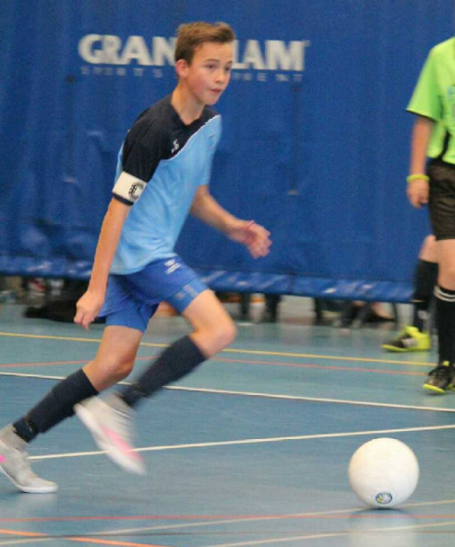

**BBQ**

**Menu**

**Breakfast**

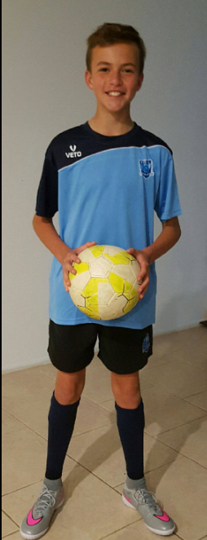

Chocolates - $1.00

Drinks - $2.00

* Sausage Sandwich - $3.00
* Steak Sandwich - $5.00

**Lunch**

* Bacon & Egg Roll - $5.00