BOOROWA IRISH FLYBALL FLING
2nd OF OCTOBER 2016
HOSTED BY
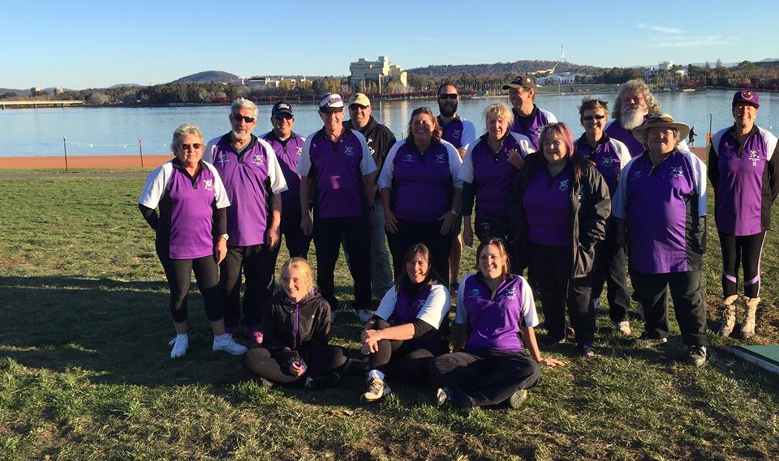
SYDNEY SCALLYWAGS
SPONSORED BY
THE BOOROWA IRISH FLYBALL FLING 2nd OF OCTOBER 2016
LOCATION:-SCOTT PARK PUDMAN ST BOOROWA NSW
ORGANISES:- SYDNEY SCALLYWAGS
JUDGES:-RON RICHARSON AND SUE NORTON
AFA REP:- CAROLYN SHRIVES
TIME STEWARDS:- MICHELLE, GAVIN AND CATHERINE
CHECK IN ;- 8AM START TIME 9AM
RACES:- 35
90 second change over
DIVISION INFORMATION:-
DIVISION 1 ARE RUNNING A SINGLE ROUND ROBIN WITH 5 RACES PER TEAM , 5 HEAT RACES (25 HEATS PER TEAM)
DIVISION 2 WILL BE RUNNING A DOUBLE ROUND ROBIN WITH 3 HEATS , 6 RACES PER TEAM, (24 HEATS PER TEAM )
*BOTH DIVISIONS WILL BE RUNNING HANDICAP RACING
*THERE WILL BE 10 MINUTE BREAK AFTER 10 RACES
*WE WILL BE STOPPING FOR THE PARADE
*LUNCH TIME TRAINING WILL BE AVAILABLE
ALL ENTRIES RECEIVE A PRIZE AND PRIZES FOR THE BOX LOADERS AND BALL SHAGGERS
AS TRADITION WE WILL BE STOPPING AT 11.40AM FOR THE STREET PARADE AND AGAIN AT (AIM) 3.30PM FOR THE FASHION PARADE JUDGED BY OUR SPECIAL GUEST………
CATERING :- KOOLIE RESCUE SAUSAGE SIZZLE AND COLD DRINKS ALL DAY
FINALLY THE MOST IMPORTANT PRIZE OF THE DAY IS THE LEON BARTON #Memorial award to be presented to the team on the day that shows the spirit of flyball. Sportsmanship, having fun and team work that shows the dogs are enjoying the day.
#Also this year we have the Christine Lehmann Memorial Award for “The dog with spirit”
#There is a Steward prize for the ring stewarding

