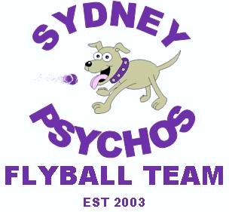

A Psychos Half Century

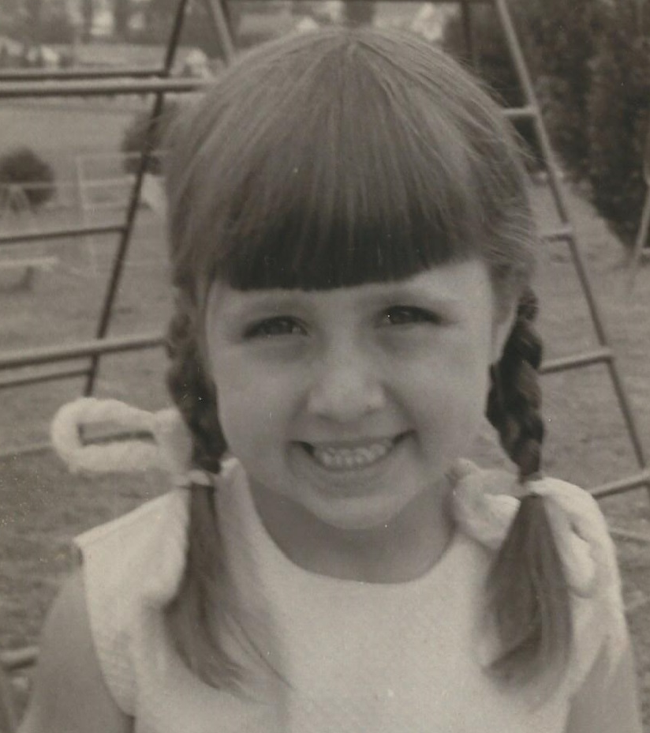
Saturday 27th August 2016

Catalogue

Competition Organiser

Ian Ferguson

Judges
Phil Lea Robyn Ferguson

Probationary Judge

Justin Murray

AFA Representative

Carolyn Shrives

Timekeepers

Richard Mellon | Michelle  Lewer | Carolyn  Shrives

Competition Notices
- Check in time is 7:30am.
- Vetting and measuring commences at 7:40am.
- Captains Meeting is at 8:00am.
- Racing begins promptly at 8:30am.
- All races will have a 90 second change over period.
- Lunch break will be 30 minutes, subject to change depending on unforeseen circumstances such as rain imminent, delay in starting or slow racing.
- There is no on site catering, so it is recommended that attendees bring their own food and beverages.
- Tea and coffee will be available.
- Due to the number of teams entered and daylight hours, there will be no training in the ring at lunchtime.
- There will be a runoff for the Maverick CDX ADX FDX trophy only if time permits.
- Team captains are to ensure that information on their team’s time sheet is correct prior to signing off at the end of the competition.
- In the event of ties on completion of round robins, places will be decided by a count back.
- All racing will be conducted under the rules and regulations of the Australian Flyball Association.
- Open racing will be conducted under the handicap rules.
- All teams are expected to supply stewards throughout the competition.

- Smoking is prohibited at this event in accordance with the Smoke-Free Environment Act 2000 (NSW) Section 6A - Smoke Free Areas - Outdoor Public Places.
- The AFA Policy 2 - Dog Behaviour Policy requires members to ensure that their dogs are under control at all times. To meet this requirement, members are to ensure that their dogs are on lead at all times within the vicinity of the competition grounds unless in crates, tethered or in the ring.
- All dog’s faeces are to be disposed of in the appropriate manner.
- Please keep grounds clean and use bins provided.

Catering

Newington Market Place
Avenue of Europe Newington
Distance: 950 metres - 5 minute drive
Includes:
- Fishbowl seafood bar and grill
- Gloria Jeans
- JAGS Ristorante
- Nhu King Hot Bread
- Subway
- Yum Yum Kebabs
- Woolworths

Veterinarians

Dundas Veterinary Hospital

12 Station Street, Dundas

Distance: 5.3 Km
Phone: 9638 7766
Saturday: 9.00am - 12.30pm and 1.00pm - 4.30pm

Animal Referral Hospital
250 Parramatta Road Homebush
Distance: 7 Km
Phone: 9758 8666
Open 24 hours

Medical Emergencies

Auburn Hospital
Hargrave Road Auburn
Distance: 4.6 Km
Emergency Department Phone: 8759 3361 / 8759 3362
Divisions and Times

 | Team | Submitted Time | Time Type | Breakout
Div 1 | Norwest Thunderdogs 2 | 17.772 | web | N/A
 | Hyper Drive | 17.967 | web | N/A
 | Sydney Psychos | 18.593 | web | N/A
Div 2 | Norwest Thunderdogs 3 | 19.178 | web | 18.178
 | Norwest Thunderdogs 4 | 19.622 | web | 18.178
 | Belconnen Speeding Bullets | 19.800 | dec | 18.700
 | SX Shining Stars | 20.200 | dec | 19.200
 | Sydney Psycho Analysts | 20.674 | web | 19.674
 | St George Havoc Hounds | 20.759 | web | 19.674
 | Sydney Psychos Phantoms | 21.237 | web | 19.674
Div 4 | Supersonics | 22.600 | dec | 21.600
 | Norwest Thunderdogs 6 | 22.750 | dec | 21.750
Div 5 | Sydney Psycho Killers | 24.020 | web | 23.020
 | Norwest Thunderdogs 7 | 24.700 | dec | 23.700
Div 6 | City Slickers | 26.454 | web | 25.454
 | Belconnen Rusty Bullets | 28.515 | web | 25.454
 | Norwest Thunderdogs 8 | 28.000 | dec | 27.000
Open (Handicap Format) | Crate Escapers | 24.500 | dec | 23.500
 | Galaxy | 20.000 | dec | 19.000
 | High Flyers | 20.000 | dec | 19.000

Racing Format
Division 1  Triple round robin  6 races per team  3 heat races | Division 2  Double round robin  6 races per team  3 heat races
Division 3  Triple round robin  6 races per team  3 heat races | Division 4 & 5 (Combined)  Double round robin  6 races per team  3 heat races
Division 6  Triple round robin  6 races per team  3 heat races | Open (Handicap)  Triple round robin  6 races per team  3 heat races
Running Order
RACE | LEFT | RIGHT
1 | Sydney Psychos | Norwest Thunderdogs 2
2 | Belconnen Speeding Bullets | Norwest Thunderdogs 3
3 | Sydney Psychos Phantoms | St George Havoc Hounds
4 | SX Shining Stars | Norwest Thunderdogs 4
5 | Supersonics | Sydney Psycho Killers
6 | Norwest Thunderdogs 7 | Norwest Thunderdogs 6
7 | High Flyers | Crate Escapers
8 | Hyper Drive | Sydney Psychos
9 | Norwest Thunderdogs 8 | City Slickers
10 | Sydney Psycho Analysts | Sydney Psychos Phantoms
11 | Norwest Thunderdogs 7 | Supersonics
12 | Galaxy | High Flyers
13 | Norwest Thunderdogs 6 | Sydney Psycho Killers
14 | City Slickers | Belconnen Rusty Bullets
15 | Norwest Thunderdogs 2 | Hyper Drive
16 | St George Havoc Hounds | Sydney Psycho Analysts
17 | Norwest Thunderdogs 3 | Norwest Thunderdogs 4
18 | Belconnen Speeding Bullets | SX Shining Stars
19 | Sydney Psycho Killers | Norwest Thunderdogs 7
20 | Crate Escapers | Galaxy
21 | Supersonics | Norwest Thunderdogs 6
22 | Belconnen Rusty Bullets | Norwest Thunderdogs 8
23 | Sydney Psychos | Hyper Drive
24 | Norwest Thunderdogs 4 | Belconnen Speeding Bullets
25 | St George Havoc Hounds | Sydney Psychos Phantoms
26 | Norwest Thunderdogs 3 | SX Shining Stars
27 | Sydney Psycho Killers | Supersonics
28 | Norwest Thunderdogs 6 | Norwest Thunderdogs 7
29 | High Flyers | Galaxy
30 | City Slickers | Norwest Thunderdogs 8
31 | Sydney Psychos | Norwest Thunderdogs 2
32 | Sydney Psycho Analysts | St George Havoc Hounds
33 | Norwest Thunderdogs 3 | Belconnen Speeding Bullets
 | LUNCH
34 | City Slickers | Belconnen Rusty Bullets
35 | Norwest Thunderdogs 4 | SX Shining Stars
36 | Crate Escapers | High Flyers
37 | Hyper Drive | Norwest Thunderdogs 2
38 | Sydney Psychos Phantoms | Sydney Psycho Analysts
39 | Supersonics | Norwest Thunderdogs 7

RACE | LEFT | RIGHT
40 | Sydney Psycho Killers | Norwest Thunderdogs 6
41 | Galaxy | Crate Escapers
42 | Norwest Thunderdogs 8 | Belconnen Rusty Bullets
43 | Hyper Drive | Sydney Psychos
44 | Norwest Thunderdogs 4 | Norwest Thunderdogs 3
45 | Sydney Psychos Phantoms | St George Havoc Hounds
46 | SX Shining Stars | Belconnen Speeding Bullets
47 | Norwest Thunderdogs 8 | City Slickers
48 | High Flyers | Crate Escapers
49 | Norwest Thunderdogs 7 | Sydney Psycho Killers
50 | Norwest Thunderdogs 6 | Supersonics
51 | Sydney Psycho Analysts | Sydney Psychos Phantoms
52 | Norwest Thunderdogs 2 | Hyper Drive
53 | Belconnen Rusty Bullets | City Slickers
54 | Galaxy | High Flyers
55 | Belconnen Speeding Bullets | Norwest Thunderdogs 4
56 | SX Shining Stars | Norwest Thunderdogs 3
57 | St George Havoc Hounds | Sydney Psycho Analysts
58 | Norwest Thunderdogs 2 | Sydney Psychos
59 | Crate Escapers | Galaxy
60 | Belconnen Rusty Bullets | Norwest Thunderdogs 8

