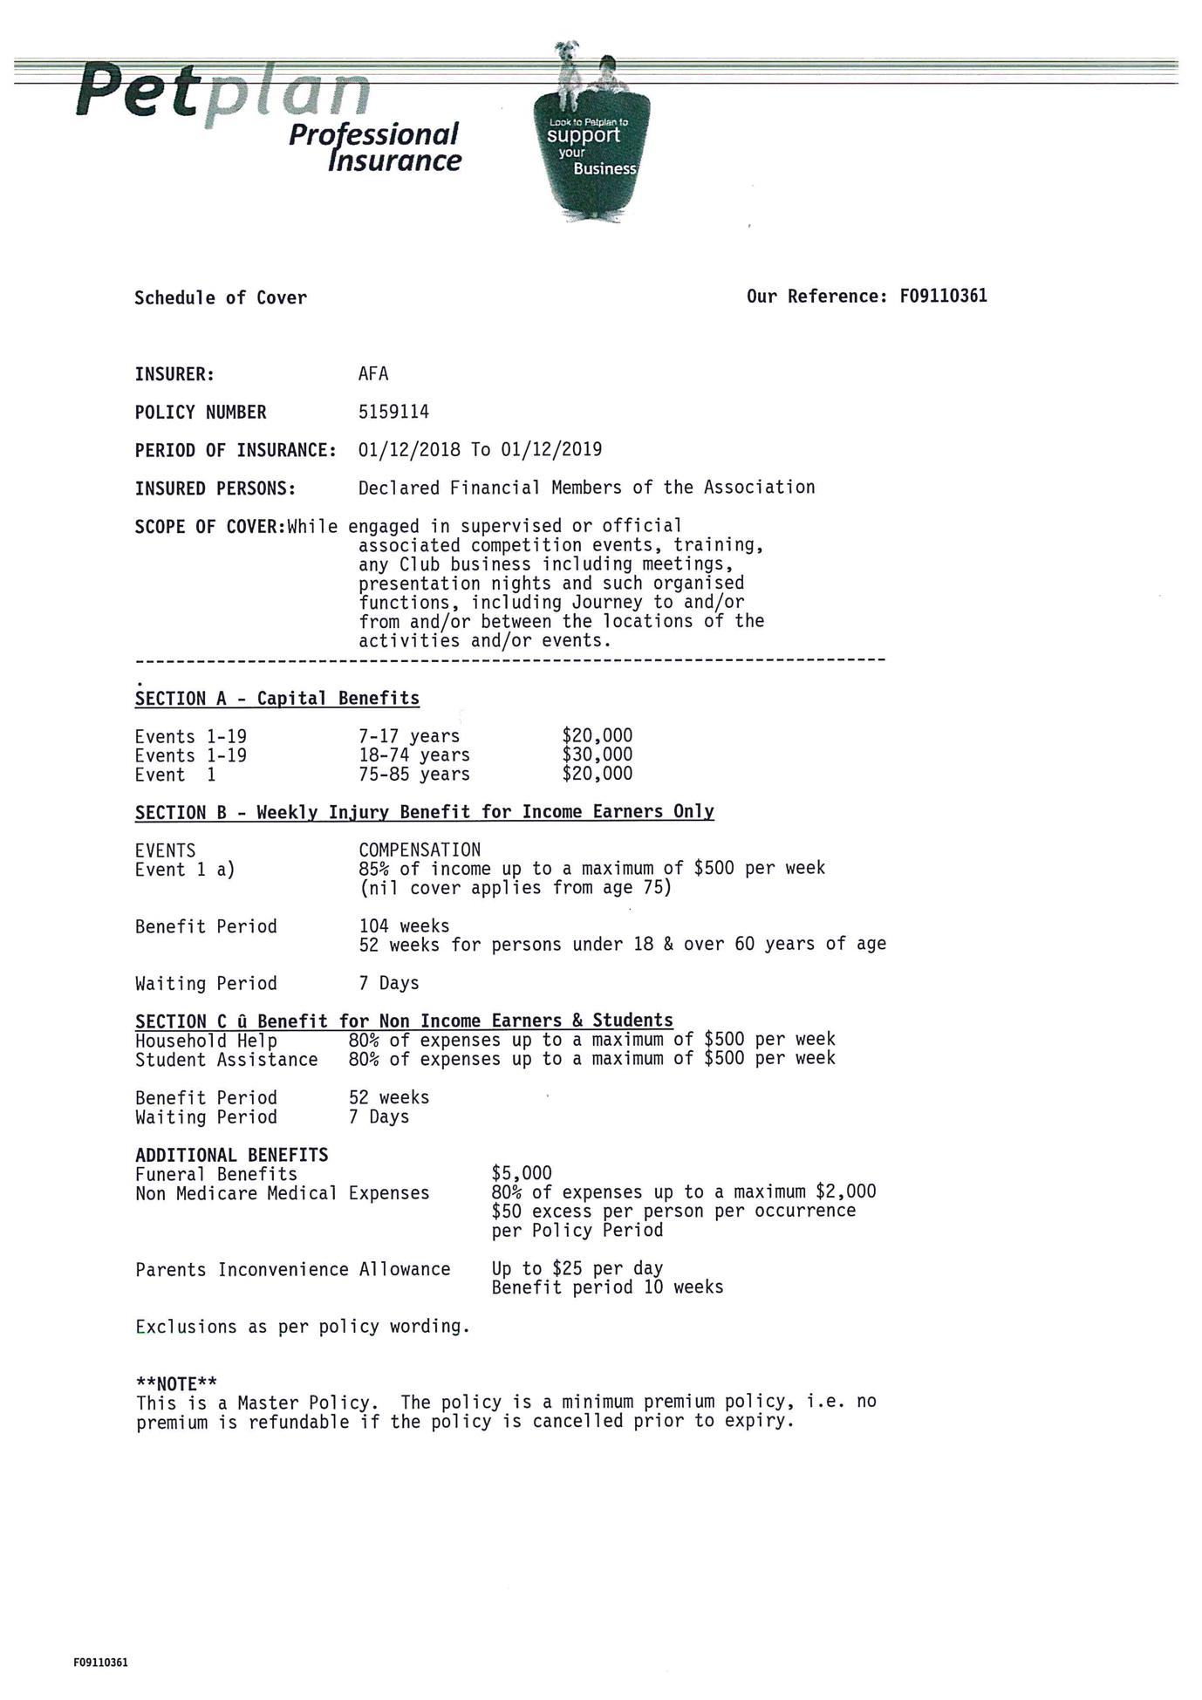
The above policy covers members in case of Death, Permanent or Temporary injury whilst participating in flyball activities. The policy is broken up into 3 sections:
SECTION A - Capital Benefits: Compensation payable as a lump sum for Death or Permanent Disablement (loss of a limb). The amount payable is listed on your schedule, and the amount of compensation payable depends on what the injury is (I have attached a list capital events 1-19).
SECTION B - Weekly Injury Benefit for Income Earners: A weekly payment to the claimant of up to 85% of their income, and up to a maximum of $500 per week. This is can be paid for a period of 104 weeks (2yrs), or until the claimant is fit to work.
SECTION C – Benefit for Non Income Earners & Students: This benefit provides Household Help, and Student Assistance to a maximum of $500 per week.
Other Benefits:
Funeral Cover: $ 5,000
Non-Medicare Medical Expenses: Up to $ 2,000

