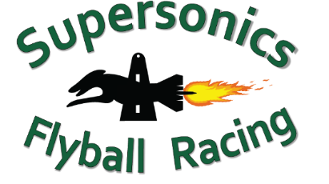


Calling All Beginners Training Day

Saturday 14th February 2026


Check In: 10am
Training Starts: 10.30am

Entries close: 6th Feb 2026

Organiser: Shireen Pitt
AFA Rep: Steven Pitt
Location: RSPCA Flyball Arena, 139 Wacol Station Rd Wacol

Cost: $10.00 per dog (one payment per club please)
Bank Details:
Supersonics Flyball Racing Club
BSB: 064 776
Account number: 1006 8983
Reference: ‘Club name’ training day
Entries are via registration form.

Format
A block of time will be allocated to each club based on the number of dogs nominated for training in the ring.
Open to dogs that have less than 20 title points.
Dogs under 12 months of age are not to use any flyball equipment as per AFA rules and policies.
A distraction dog may be taken into the ring to assist. Please ensure they are included on the training day form.
The fence will be in place down the middle of the ring.

Rules
All Australian Flyball Association rules, regulations and polices apply.
All dogs must be registered with the AFA and have current CRN.



Venue Rules
Kitchen: The kitchen will be available for all competitors to use at all times. Free tea and coffee will be available for competitors. Please wash used mugs and place in dishwasher.
Dogs: Dogs are not permitted off lead anywhere on the RSPCA grounds. Dogs are not to be toileted near the War Memorial.
Grounds: Please keep the arena and field clean, using the bins provided and always pick up after your dog.
Alcohol: No alcohol is to be consumed during the event.

We hope everyone has a great day and benefits from the training!!

