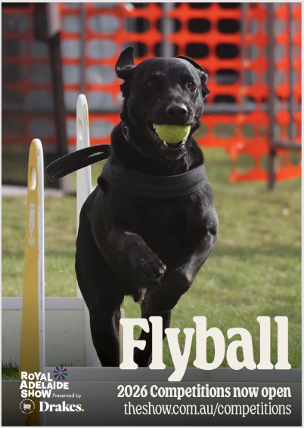
Adelaide Royal Show Flyball Competition, 13th September 2026, CAF1307
Welcome and thank you for entering our Adelaide Royal Show competition. Special welcome to the teams from Berwick who have made the trip over to race with us.
GENERAL INFORMATION
Our competition will be held on the Southern end of the Main Arena, Adelaide Showgrounds, Wayville. This is the opposite end of the Arena than we were last year, closest to Dairy Cattle/Leader St end of the Showgrounds.
Gates open: 6.30 am

Check in and measuring: 7.30 am

Judges Briefing: 7.45 am

Racing starts: 8.00 am

ENTRY TO SHOWGROUNDS

Please note: Your Carpark tickets are for Leader St, Wayville in either for Carpark No. 2 or 3. Please check your ticket. Entry into the showgrounds is via the gate in Carpark no.3. (See map) The gates will open at 6.30am.

The Royal Agricultural and Horticultural Society makes every attempt to ensure that all information contained within this schedule is correct at the time of printing, however the RA&HS reserves the right to change such details as may be required. Team captains will be notified as soon as possible to any changes in circumstances.

AFA MEMBERSHIP
All exhibitors must be current financial members of the Australian Flyball Association www.flyball.org.au.

RAHS MEMBERSHIP

It is not a requirement of entry to the Flyball Competition to be a member of the Royal Agricultural & Horticultural Society of SA Inc, however, we do ask you to consider becoming a member of the Society, which will greatly assist us in continuing to grow, promote and support South Australia’s vital Primary Industries. There are numerous other benefits to membership, including unlimited entry to The Royal Adelaide Show, access to Members Dining and Bar facilities and even discounts for Taste of the Best and The Adelaide Showground Caravan Park.
Further information can be found at https://www.rahs.com.au/membership

CONTACT US
Post RA&HS – Flyball Section PO Box 108, GOODWOOD, SA 5034
Email entries@adelaideshowground.com.au
Phone (08) 8210 5211 (Between 9.00 am - 5.00 pm Monday to Friday)
Website www.theshow.com.au

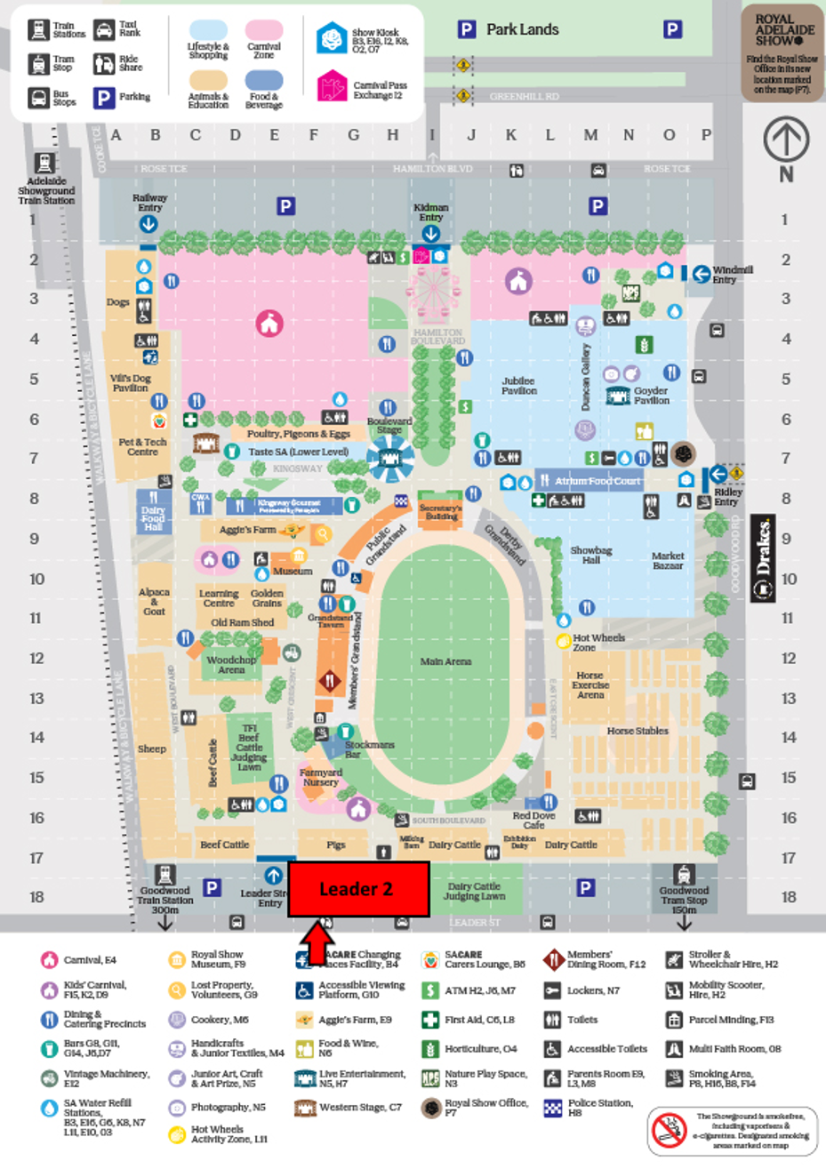
FLYBALL
Leader 3

AUTHORISED VEHICLE ACCESS
For those who have been given permission for vehicle access to drive on to the showgrounds to transport gear, please enter through the Leader St Main Gate next to Carpark 2. Vehicles are to unload equipment at the Area before proceeding directly to the Horse Stable Precinct Parking area. Vehicles will remain parked in this location for the duration of the event and may exit via Leader St Gate 3 following pack down. See the maps below for vehicle route. All cars must be on and parked by 7am. Please follow Showground staff directions and reduced speed limits.

Car entry through Leader St Main Gate (Authorised Cars Only)
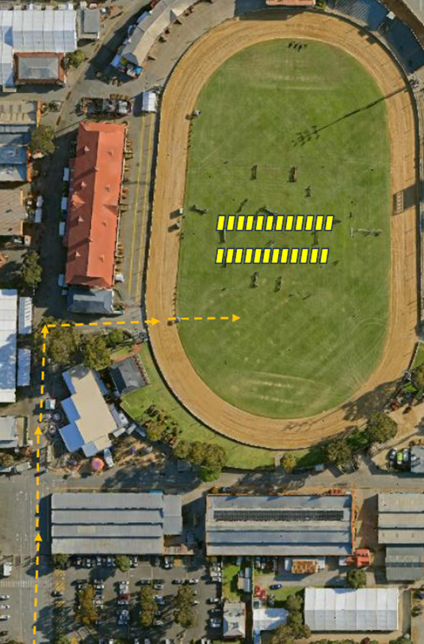
Car route to Horse Stable Parking Area & Exit route via Leader St Carpark 3
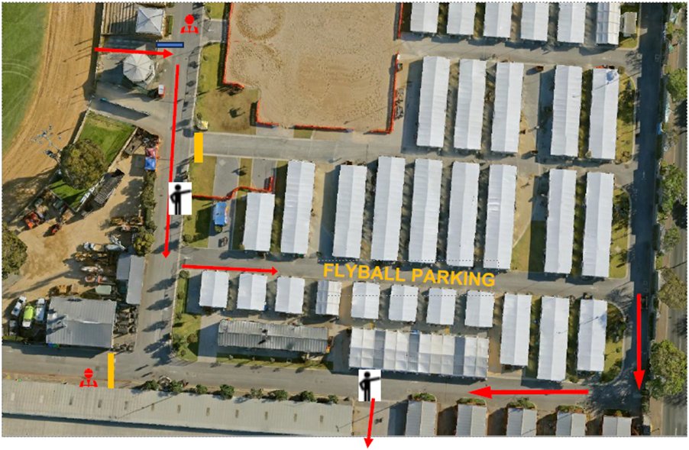

PACK DOWN
Racing needs to be finished by 3pm and pack up completed by 3.45pm
Transporting Gear
An allocated Adelaide Show ground crew member will be assigned to our area to assist in pack down. A large flatbed trailer will be available for movement of equipment. All the equipment is to be loaded on the trailer and transported to the cars parked in the horse stable area. Multiple trips may be required to relocate all the equipment. If suitable, one of the larger vehicles may be arranged to assist transporting all the gear. Please follow showground staff directions.
Once equipment pack up is complete everyone must exit through the Leader St Carpark 3 gate. Dogs will only be permitted to exit through this gate.

GENERAL REGULATIONS
Exhibitors are reminded that the Society’s General Regulations apply to all sections of the Show. A copy of the General Regulations can be obtained from the Society’s website at www.theshow.com.au or from the Society’s Administration Office.
Exhibitors should note that the General Regulations contain a number of provisions relevant to competitions and this Schedule including but not limited to, offences, penalties, prohibited drugs. As those conditions apply in addition to the regulations contained within this schedule, Exhibitors should familiarise themselves with the General Regulations.

SPECIAL REGULATIONS
Exhibitors are reminded that the Special Regulations contained within this Schedule are merely supplementary to and subject to the General Regulations.
The Society shall have the authority to take any necessary action under these Special Regulations.

WITHDRAWALS
All withdrawals must be made in writing and can be sent via email to entries@adelaideshowground.com.au or faxed to (08) 8210 5222. Emailed withdrawals must include “Withdrawal” in the subject line and the section (eg Flyball section), exhibitor name, class number/s, exhibit number (if known) and exhibit name (if applicable). Withdrawals must be made at least 24 hours prior to judging.

REFUNDS
No refund of entry fees will be made after the closing date of entries as per RA&HS policy.

YOUR PRIVACY
By exhibiting at The Royal Adelaide Show you acknowledge that you have read and agree to the privacy of the RA&HS which can be viewed here https://show.com.au/contact-us/
In relation to your entry into a competition we may automatically use and/or disclose your personal information to :
-Communicate competition information to you such as entry opening dates, delivery and collection details and entry ticket distribution.
-Publish competition results both online and in printed results listings
-Publish competition entries in Competition Catalogues
-Advise sponsors of competition prize winners for distribution of prizes from both the RA&HS and sponsors
By entering into a competition you consent to your contact details being provided to the sponsors of that competition for the purpose of distributing your prize. You also consent to your name, suburb and postcode being listed in a competition catalogue and, if you are a prize winner your name in competition results.
If you do not wish for your name and address to be printed in a competition catalogue, please ensure that you select the ‘Keep Private’ option in your online exhibitor profile.

MEASURING
At the discretion of the team, dogs jumping less than 14 inches may be measured by the measuring Judge and a second official (Judge, AFA Representative or an experienced official appointed by the accredited AFA Representative) during times designated by the host club. A dog must be entered in the competition in order to have its height recorded on a Height Card Application (Form C.8).

THANK YOU
Thank you to the Royal Agricultural & Horticultural Society of SA for hosting this competition and giving us a chance to showcase Flyball on the main arena.
Thank you to the officials and helpers involved in making this competition happen:

- AFA Judges: Martin Watt & Jess Baker
- AFA Representative: Melissa Jolley
- Time Keepers: Alli Dawson, Michelle Stokes
- Stewards: Veronica, Wayne, Eddie & Pete
- All those helping with Box Loading and Ball Shagging
- Jeremy Ellis for transport of all the Flyball gear

EXHIBITING INFORMATION
This event is sanctioned by the Australian Flyball Association Inc. As such, it will be run in accordance with the Rules and Policies of the Australian Flyball Association Inc, including rules currently on trial.

BITCHES
Bitches in season are not permitted on the Showground.

COMPETITION FORMAT
Division 1 – OPEN Handicap – 4x RR at 3 Heats. 8 races per team =24 Heats
Division 2 – OPEN Handicap – 4x RR at 3 Heats. 8 races per team =24 Heats

The 0.50 second break out rule will apply. In case of a combined division round robin, the breakout that is relevant to the team’s division will apply.
Points are awarded for each race (i.e. a team must win two out of three heats OR three out of five heats to win the race and hence the race points). The points will be tallied, and the team with the most race points will win the division.
In the case of competition points being equal, the tie will be resolved as follows:

Count back based first on head to head RACE wins during competition, where more than two teams are tied and count back for each team shall be the total RACE wins scored against all of the teams that are tied (the combined number of wins).
If two teams are still even the teams are compared on head to head heats.
If two teams are still even - then fastest heat time head to head decides the winner.

CHANGE OVER TIME
The Change Over time is 3 minutes.

PRIZES
First to fifth & commended place ribbons will be awarded.
2 Sashes will be awarded for Judge's Choice

COMPETITOR AREA

The Show is providing x1 3x3m marquee per team set up around the perimeter of the arena.
Teams are welcome to bring x1 extra 3x3m shelter per team of their own if they need more room. These need to be set up next to the existing shelters.

Please keep your dogs within the fenced Flyball area at all times during the competition. Dogs are not permitted in the showgrounds or amongst the general public. Upon completion of the competition please follow the map above and exit the grounds through Leader St Carpark 3 gate. Dogs will not be permitted through any other exit gate.

VETERINARY SERVICES

The nearest veterinary services are:

Wayville Animal Hospital
321 Young St, Wayville SA 5034
Phone: (08) 8351 6066
Open Sat: 8am-1pm

SASH Adelaide 24/7 Emergency Vet
99 Rundle St, Kent Town SA 5067
Phone: (08) 8133 5300
Open 24 hours

Greencross Vet Centre & AVSARC
102 Magill Rd, Norwood SA 5076
Phone: (08) 8132 0533
Open 24 hours

Thanks to everyone for coming. Especially our interstate guests. Wishing you all Good Luck and Happy Racing! Run Fast and Clean!

TEAMS
Club |  |  | OPEN |  |  |  |  |  |  |  |  |  | Team |  |  | Paramedics
Captain |  |  |  | Carmel Nottle |  |  |  |  |  |  |  |  | Declared Seed Time |  |  |  | 26.000
Dogs Name |  |  |  |  | CRN |  |  | Jump Height |  |  | Handler Name |  |  |  |  |  | Breed
Eddie |  |  |  |  | 2507C |  |  | 11 |  |  | Carmel Nottle |  |  |  |  |  | Labrador Retriever
Dusty |  |  |  |  | 2984B |  |  | 12 |  |  | Brett Thomas |  |  |  |  |  | Australian Sheperd
Zoe |  |  |  |  | 3434A |  |  | 12 |  |  | Karen Mingham |  |  |  |  |  | Rough Collie
Mia |  |  |  |  | 3637A |  |  | 7 |  |  | Judi Przibilla |  |  |  |  |  | Spoodle
Sasha |  |  |  |  | 2817A |  |  | 10 |  |  | Scott Cousins |  |  |  |  |  | Border Collie
Charli |  |  |  |  | 3620A |  |  | 11 |  |  | Sarah Muir |  |  |  |  |  | Groodle
Club |  |  | OPEN |  |  |  |  |  |  |  |  |  | Team |  |  | Para Barking Brigade
Captain |  |  |  | Christina Dalla Valle |  |  |  |  |  |  |  |  | Declared Seed Time |  |  |  | 20.500
Dogs Name |  |  |  |  | CRN |  |  | Jump Height |  |  | Handler Name |  |  |  |  |  | Breed
Cea |  |  |  |  | 3460A |  |  | 10 |  |  | Belinda Shepley |  |  |  |  |  | STAFFY mix
Baci |  |  |  |  | 758C |  |  | 11 |  |  | Christina Dalla Valle |  |  |  |  |  | Australian Shepherd
Callie |  |  |  |  | 3606A |  |  | 7 |  |  | Tracey King |  |  |  |  |  | Labradoodle
OLLIE |  |  |  |  | 3403A |  |  | 15 |  |  | RAY SWEETING |  |  |  |  |  | BORDER COLLIE
Tux |  |  |  |  | 3523A |  |  | 15 |  |  | Steve Olive |  |  |  |  |  | Border Collie
Club |  |  | OPEN |  |  |  |  |  |  |  |  |  | Team |  |  | Para Swaggers
Captain |  |  |  | Rebecca Knapp |  |  |  |  |  |  |  |  | Declared Seed Time |  |  |  | 23.500
Dogs Name |  |  |  |  | CRN |  |  | Jump Height |  |  | Handler Name |  |  |  |  |  | Breed
Rumble |  |  |  |  | 657C |  |  | 10 |  |  | Rebecca Knapp |  |  |  |  |  | Australian Shepherd
Treble |  |  |  |  | 2166B |  |  | 12 |  |  | Alex Stapledon |  |  |  |  |  | Australian Shepherd
Quill |  |  |  |  | 2166C |  |  | 11 |  |  | Alex Stapledon |  |  |  |  |  | Australian Shepherd
Gracie |  |  |  |  | 3346A |  |  | 15 |  |  | Jessica Stroet |  |  |  |  |  | German Shorthaired Pointer
Lily |  |  |  |  | 3520A |  |  | 7 |  |  | Wendy Muir |  |  |  |  |  | Moodle
Alegra |  |  |  |  | 3218B |  |  | 11 |  |  | Jeremy Ellis |  |  |  |  |  | Bergamasco Shepard
Club |  |  | OPEN |  |  |  |  |  |  |  |  |  | Team |  |  | Berwick Boltz
Captain |  |  |  | Jenni Veitch |  |  |  |  |  |  |  |  | Declared Seed Time |  |  |  | 17.500
Dogs Name |  |  |  |  | CRN |  |  | Jump Height |  |  | Handler Name |  |  |  |  |  | Breed
Forrest |  |  |  |  | 1174E |  |  | 11 |  |  | April Smith |  |  |  |  |  | Whippet
Ned |  |  |  |  | 3110C |  |  | 15 |  |  | Sam Hartnett |  |  |  |  |  | Kelpie
Switch |  |  |  |  | 772D |  |  | 7 |  |  | Michael Perry |  |  |  |  |  | Jack Russel x Foxie
Drift |  |  |  |  | 772G |  |  | 15 |  |  | Sally Laity |  |  |  |  |  | Border collie
Stella |  |  |  |  | 2237F |  |  | 10 |  |  | Linda Hutchison |  |  |  |  |  | Kelpie x
Hex |  |  |  |  | 3602A |  |  | 11 |  |  | Adam Doyle |  |  |  |  |  | Border Collie
Club |  |  | OPEN |  |  |  |  |  |  |  |  |  | Team |  |  | Berwick Pickles
Captain |  |  |  | Jenni Veitch |  |  |  |  |  |  |  |  | Declared Seed Time |  |  |  | 16.300
Dogs Name |  |  |  |  | CRN |  |  | Jump Height |  |  | Handler Name |  |  |  |  |  | Breed
Millie |  |  |  |  | 1174C |  |  | 11 |  |  | April Smith |  |  |  |  |  | Kelpie x whippet
Midge |  |  |  |  | 3110A |  |  | 9 |  |  | Sam Hartnett |  |  |  |  |  | Kelpie
Rozz |  |  |  |  | 3110B |  |  | 11 |  |  | Adam Doyle |  |  |  |  |  | Kelpie
Uma |  |  |  |  | 823E |  |  | 10 |  |  | Sally Laity |  |  |  |  |  | Border collie
Etzio |  |  |  |  | 823F |  |  | 11 |  |  | Michael Perry |  |  |  |  |  | Border collie
Rydor |  |  |  |  | 2670B |  |  | 10 |  |  | Debra Moody |  |  |  |  |  | Border Collie
Club |  |  | OPEN |  |  |  |  |  |  |  |  |  | Team |  |  | Cruised Over
Captain |  |  |  | Melissa Jolley |  |  |  |  |  |  |  |  | Declared Seed Time |  |  |  | 20.200
Dogs Name |  |  |  |  | CRN |  |  | Jump Height |  |  | Handler Name |  |  |  |  |  | Breed
Arlo |  |  |  |  | 3508A |  |  | 7 |  |  | Elizabeth Eichner |  |  |  |  |  | Border Collie
Ben |  |  |  |  | 3368A |  |  | 7 |  |  | Ron Butler |  |  |  |  |  | Australian Shepherd
Loki |  |  |  |  | 3358A |  |  | 7 |  |  | Jordan Hutchesson |  |  |  |  |  | Border Collie Cross
Presto |  |  |  |  | 909B |  |  | 7 |  |  | Timothy Hall |  |  |  |  |  | Nova Scotia Duck Tolling Retriever
Tona |  |  |  |  | 3359A |  |  | 7 |  |  | Virginie Bajut |  |  |  |  |  | Nova Scotia Duck Tolling Retriever
Clay |  |  |  |  | 3358B |  |  | 7 |  |  | Jordan Hutchesson |  |  |  |  |  | Australian Koolie





