BBQ MENU

Bacon & Egg Rolls $5.00

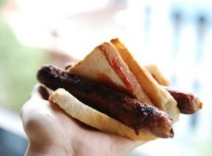

Sausage Sizzle $2.50

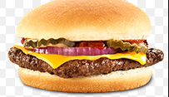

Cheeseburger $5.00

The Lot (cheeseburger / bacon / egg / combo) $6.00

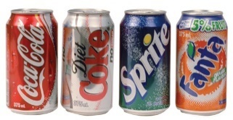

Soft Drink $2.00

Water $1.50

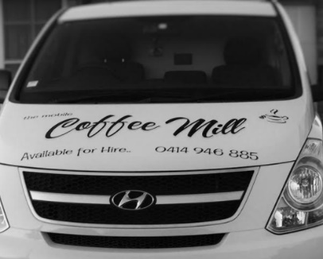
Coffee Van

