BOOROWA IRISH FLYBALL FLING
4TH OF OCTOBER 2015
HOSTED BY
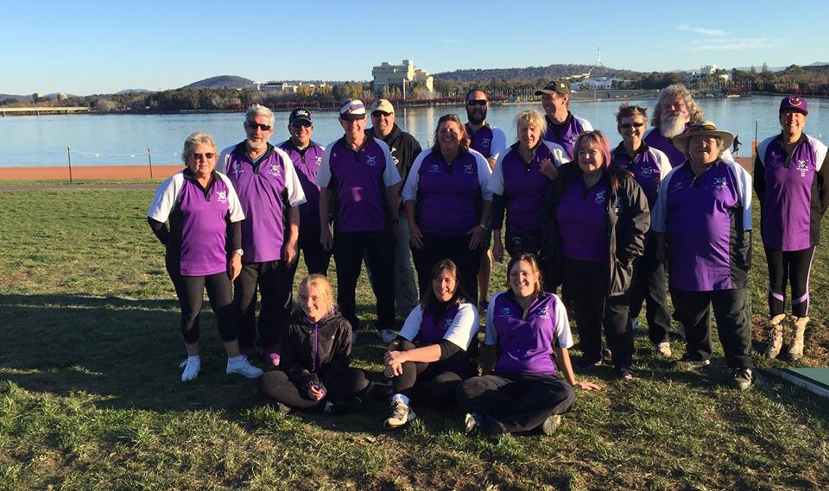
SYDNEY SCALLYWAGS
SPONSORED BY

