NEW LOCATION FOR THE BOOROWA FLYBALL FLING. OCTOBER 2ND 2016
Attention competitors due to the rain the Boorowa committee has moved us up to higher ground
We have relocated to St Josephs Primary School grounds (see map and Pictures below) Scotts street When you enter Boorowa, Turn Left at the post office (Queens St) follow road to the end turn left on Scotts street then the gate entry is a quick right.
Yes we can still camp, just need to make sure we pickup after the dogs, and keep the area clean.
Please see map for camping area.
Any questions please contact me
Verdelle
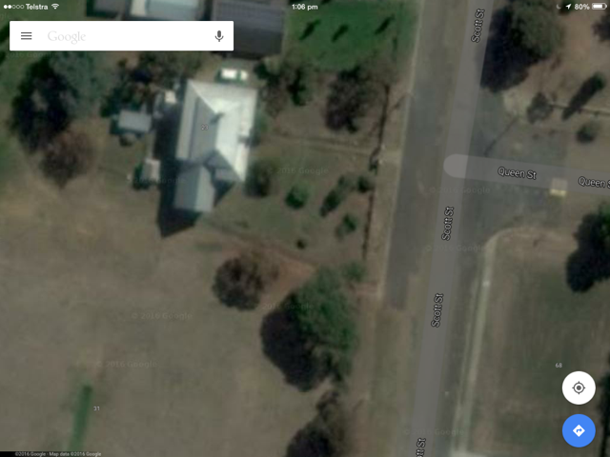
Flyball ring
Gate entry
camping
