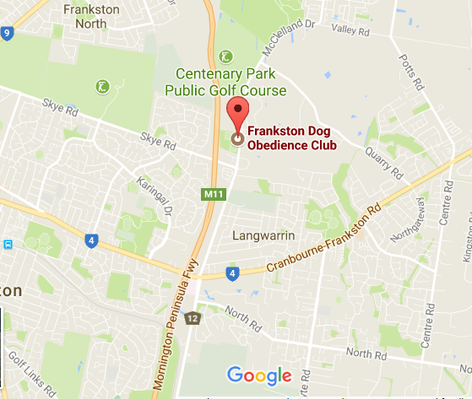

***Frankston Dog Obedience Club***

*Centenary Park*

*McClelland Dr, Frankston VIC 3199*

**Where can you find us?**