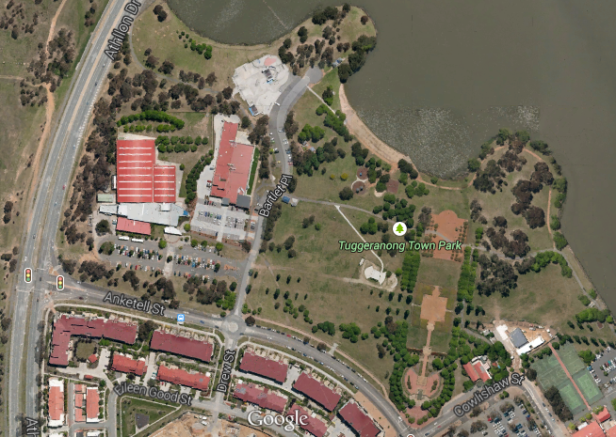
Toilets
Drop off and car park
*Flyball*
Old location
Please note that we have shifted to a different area of Tuggeranong Town Park this year – to the area marked “Flyball” in the above map. For reference, our previous location is marked “Old location”. Competitors will not be able to drive onto the grounds this year, but can stop in Bartlett Place to drop off and pick up equipment. There is a car park at Bartlett Place (indicated by a red arrow) right next to where we will be competing – no car parks are reserved for us, but they are free and available for use by anybody. If you are not able to park in Bartlett Place, you will need to park further away such as on Anketell or surrounding streets.

