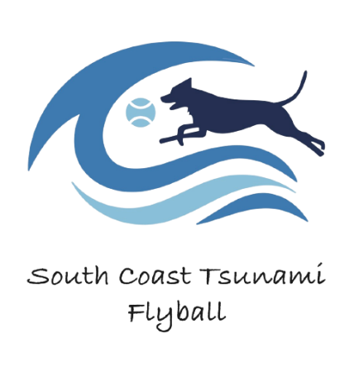
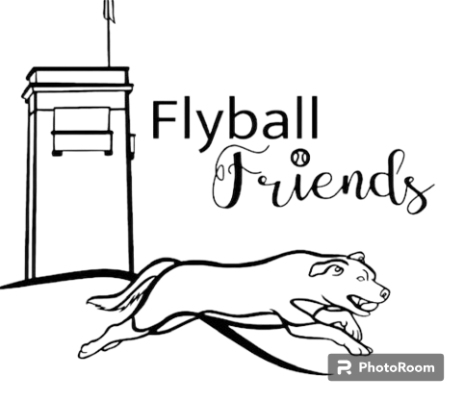

SOUTH COAST TSUNAMI & FLYBALL FRIENDS

PRESENT:

FUN AT THE BEACH COMP

SATURDAY 19TH AUGUST 2023
+
SUNDAY 20TH AUGUST 2023

KIOLOA BEACH CARAVAN PARK
635 MURRAMARANG ROAD
KIOLOA, NSW
Welcome to the 2023 Fun at the Beach Racing Event

Our sincere thanks go to the Judges, Timekeepers, Stewards, AFA Rep and all who have helped to make this event a success.

Comp Organiser: Fiona Bulman
Judges: Christine Bates, Verdelle Townsend
AFA Rep: Amanda Pennicuik

Itinerary:

SATURDAY
Check in: 11am
Judge’s Briefing: 11:30am
Racing starts: 12:30am

SUNDAY
Check in: 8am
Judge’s Briefing: 8.30am
Racing starts: 9am

TRAINING IN THE RING
TIR will be held both days for beginner dogs. There will be 3 sessions over the course of the 2 days.

Competition Race Format

REGULAR RACING

Division 1 - 3 teams, HANDICAPPED Racing
Triple RR, 3 x 5 heat races

Division 2 - 4 teams, HANDICAPPED Racing
Triple RR, 2 x 5 heat races

OPEN RACING

5 teams, HANDICAPPED Racing
Double RR, 2 x Best of 5 heat races

In the event of tied places at the end of the competition, the AFA countback rule will apply

Rules & Regulations

All Competitors must ensure dogs are on lead when not racing and all dog faeces are disposed of in the appropriate manner.
All racing will be conducted under the rules and regulations of the Australian Flyball Association.

Break Outs
The AFA Break Out rule will be applied for all breakout occurrences.
Changeover Times
Teams will have 90 sec from the end of the proceeding race to have their box and jumps set up and be ready to race.
Stewarding
All teams are requested to participate in the stewarding throughout the day to ensure the smooth running of the competition.

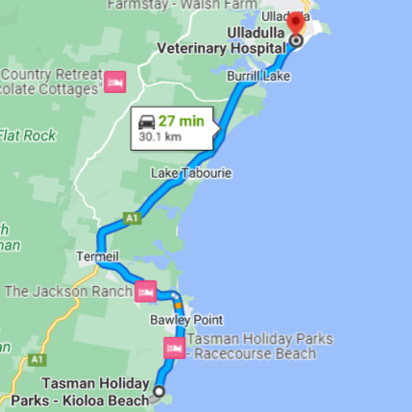
Nearest Vet
Ulladulla Vet Clinic
249 Princes Highway
Ulladulla, NSW, 2539

Ph. (02) 4455 5339
RAFFLE

Tickets:
1 ticket - $2
3 tickets - $5
7 tickets - $10

We have some great prizes on offer! You got to be in it to win it!
Raffle will be drawn before presentation.

CATERING

We will be hosting a sausage sizzle for dinner Saturday night and bacon & egg rolls for breakfast Sunday morning. All welcome to join us.
WE WOULD LIKE TO THANK OUR RAFFLE PRIZE SPONSORS:

DIVISION SPLITS
Div | Team Name | Seed Time | Dec Time | Breakout
1 | Norwest Thunderdogs 1 | 16.84 |  | 16.3
1 | Norwest Thunderdogs 4 |  | 18.7 | 18.2
1 | Tidal Wave |  | 19.3 | 18.8
2 | Pawpedoes |  | 21.7 | 21.2
2 | Rocky Hill Racers |  | 22.5 | 22.0
2 | Norwest Thunderdogs 6 | 22.87 |  | 22.3
2 | MAD Dash | 24.754 |  | 24.2
OPEN | Thunderdog Tornado |  | 18.2 | 17.7
OPEN | Canberra X-traordinary |  | 18.5 | 18
OPEN | Zoomies |  | 22 | 21.5
OPEN | We Opened This |  | 22.1 | 21.6
OPEN | Flyball Friends |  | 28 | 27.5

RUNNING ORDER - DAY 1
Race # | Division | Left Lane | Right Lane
1 | 1 | Tidal Wave | Norwest Thunderdogs 1
2 | Open | Flyball Friends | Canberra X-traordinary
3 | Open | We Opened This | Thunderdog Tornado
4 | 2 | MAD Dash | Pawpedoes
5 | 2 | Rocky Hill Racers | Norwest Thunderdogs 6
6 | 1 | Norwest Thunderdogs 4 | Tidal Wave
7 | Open | Zoomies | Flyball Friends
8 | Open | Canberra X-traordinary | We Opened This
Afternoon Tea Break – 15 mins
9 | Open | Thunderdog Tornado | Zoomies
10 | Open | We Opened This | Flyball Friends
11 | 2 | Pawpedoes | Norwest Thunderdogs 6
12 | 2 | MAD Dash | Rocky Hill Racers
13 | 1 | Norwest Thunderdogs 1 | Norwest Thunderdogs 4
14 | Open | Canberra X-traordinary | Zoomies
15 | Open | Flyball Friends | Thunderdog Tornado
16 | 2 | Norwest Thunderdogs 6 | MAD Dash
17 | 2 | Pawpedoes | Rocky Hill Racers
18 | 1 | Norwest Thunderdogs 1 | Tidal Wave
19 | Open | Zoomies | We Opened This
20 | Open | Thunderdog Tornado | Canberra X-traordinary
End Day 1

Race # | Division | Left Lane | Right Lane
21 | 1 | Tidal Wave | Norwest Thunderdogs 4
22 | Open | Canberra X-traordinary | Flyball Friends
23 | Open | Thunderdog Tornado | We Opened This
24 | 2 | Pawpedoes | MAD Dash
25 | 2 | Norwest Thunderdogs 6 | Rocky Hill Racers
26 | 1 | Norwest Thunderdogs 4 | Norwest Thunderdogs 1
27 | Open | Flyball Friends | Zoomies
28 | Open | We Opened This | Canberra X-traordinary
Morning Tea Break – 15 mins
29 | 1 | Norwest Thunderdogs 4 | Tidal Wave
30 | Open | Zoomies | Canberra X-traordinary
31 | Open | Thunderdog Tornado | Flyball Friends
32 | 2 | Norwest Thunderdogs 6 | Pawpedoes
33 | 2 | Rocky Hill Racers | MAD Dash
34 | 1 | Tidal Wave | Norwest Thunderdogs 1
35 | Open | Zoomies | Thunderdog Tornado
36 | Open | Flyball Friends | We Opened This
37 | 2 | MAD Dash | Norwest Thunderdogs 6
38 | 2 | Rocky Hill Racers | Pawpedoes
39 | 1 | Norwest Thunderdogs 1 | Norwest Thunderdogs 4
40 | Open | We Opened This | Zoomies
41 | Open | Canberra X-traordinary | Thunderdog Tornado
End Day 2
RUNNING ORDER - DAY 2

Day/Time | Club | Time Allocated
Saturday morning 10am – 11am | Norwest | 20 mins
 | Sydneysiders/CDC | 10 mins
 | Manly | 15 mins
 | Scallywags | 15 mins
Saturday afternoon tea break | Tsunami | 15 mins
Sunday morning  tea break | Flyball Friends/We Got This | 15 mins
TRAINING IN THE RING

Thank you for supporting our comp, we hope you have a great weekend & please have a safe trip home!

