QR Code to Sign In

Required:
- Mobile Phone / Device with a camera
- Each individual present at the event must Sign In

INSTRUCTIONS:
- Open Mobile Phone / Device camera
- Hold camera over the picture below (QR Code)
- A link will appear at the top of your screen.
- Click the link to take you to the Sign In form.
- Enter your Name.
- Enter your Phone or Email detail.
- Answer the Declaration questions.
- Press SUBMIT.

If another response is needed (someone present does not have a phone, etc. select ‘Submit another response’.

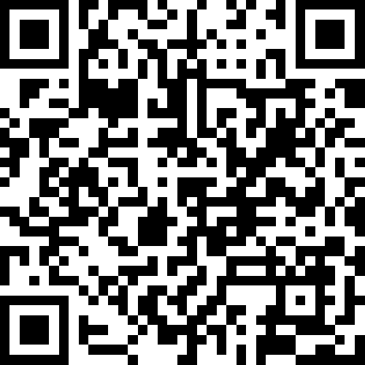

For assistance – see a Maximum Velocity member.

