BUY NOW – Tickets $10 each

Flyball Box  (made by Phil Lea)  Set of Flyball Jumps  (made by Les Scott)  Jump Aid  (made by Les Scott)  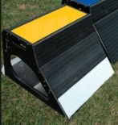  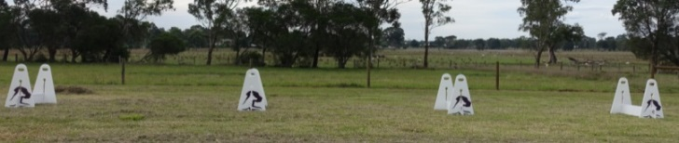  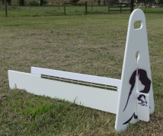  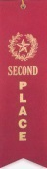  =================================================================  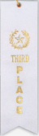  Order Form:  Name : ________________________________ CRN: _____________  Email: ________________________________________________________  Phone: __________________ Club: ________________________________  You must fill in Order Form and either email it (if paying via EFT) or post Order Form with your cheque (if paying by cheque). | EFT payments can be made to the following account:  Bank Account Name: Sydney Flyball Associates  BSB No: 012 357  Account No. 268864803  Reference: [ Enter your CRN - Raffle ]  You MUST enter your CRN-RAFFLE in the reference field so that payments can be allocated against your CRN and tickets confirmed.  Email Order Form to: pbyrne154@gmail.com  ------------------------------------------------------------------------------------------  Cheque payments can be made by filling in the Order Form and posting with a cheque.  Payable to: Sydney Flyball Associates  Send to: Mrs Patricia Byrne  154 Pebbly Hill Road, Cattai NSW 2756  -------------------------------------------------------------------------------------------  ** A copy of your tickets can be picked up at check-in on the Saturday (tickets will be automatically in the draw) **  Raffle drawn on 18th September, 2016 (during presentations)

