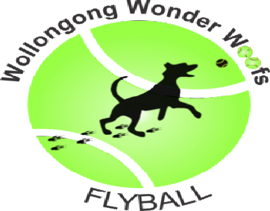
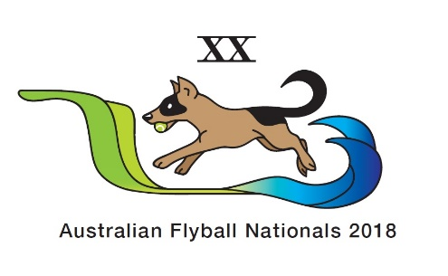

2018 Flyball Nationals
Local Accommodation

There is a good selection of reasonably priced pet friendly and other accommodation in the local area from between 10 minutes and an hour’s drive from the Kiama Quarry Sports Complex. Accommodation ranges from powered sites and cabins near the beaches to family size accommodation inland.

Some examples of the accommodation available and the approximate distance from the event are:

Accommodation | Address | Information | Distance from grounds  (approx.)
Allwood Cottage | 4 Fitzroy Street Kiama NSW 2533  0415 444 619  https://www.stayz.com.au/accommodation/nsw/south-coast/kiama | Pet friendly – sleeps 6 | 1 km
Bombo Hideaway | 24 Horthersal Street Kiama NSW 2533  https://kiama.com.au/listing/stay/pet-friendly/bombo-hideaway | Pet friendly – sleeps 3 | 1 km
Kendalls on the Beach | 33 Bonaira Street Kiama NSW 2533  02 4232 1790  https://www.kiamacoast.com.au/kendalls-on-the-beach/ | Pet friendly powered and unpowered sites | 3 km
Werri Beach Holiday Park | Pacific Avenue Gerringong NSW 2534  02 4234 1285  https://www.kiamacoast.com.au/werri-beach-holiday-park/facilities/#camp | Pet friendly grass and concrete sites available | 11 km
Carinya Cottage | 0402 557 649  cheryl@coastalserenity.com.au  http://www.coastalserenity.com.au/contact.php | Pet friendly – sleeps 11 | 14 km
Shellharbour Beachside Tourist Park | 1 John Street Shellharbour NSW 2529  02 4295 1123  info@shellharbourtouristpark.com.au  http://www.shellharbourtouristpark.com.au/contact-us/ | 70 pet friendly powered sites | 14 km
Tall Timbers | 47 Shoalhaven Heads Road Shoalhaven Heads NSW 2535  02 4448 7270  http://allswell.com.au/community/tall-timbers/?holiday=1#contact | 12 sites and 2 pet friendly cabins | 27 km
Seven Mile Beach Holiday Park | 200 Crooked River Road Gerroa NSW 2534  02 4234 1340  sevenmile@kiamcoast.com.au  https://www.kiamacoast.com.au/seven-mile-beach-holiday-park/contact-us/ | Pet friendly powered and unpowered sites | 15 km
Wollongong Tourist Park | Windang – Fern Street Windang NSW 2528  02 4297 3166  windangtp@wollongong.nsw.gov.au  Corrimal – Lake Parade East Corrimal NSW 2518  02 4285 5688  corrimaltp@wollongong.nsw.gov.au  Bulli – 1 Farrell Road Bulli NSW 2516  02 4285 5677  bullitp@wollongong.nsw.gov.au  http://www.wollongongtouristparks.com.au | 5 sites – dogs under 10kg | Windang – 19.7 km  Corrimal – 43 km  Bulli – 47 km
The Tree House | 16 Jamieson Road North Nowra NSW 2541  0434 609 516  bookings@accomodationnowra.com.au  http://accomodationnowra.com/ | Pet friendly house – sleeps 6 adults | 42 km
Red Dog Retreat | Sally Larsen  0407 606 873  http://reddogretreat.com/contact/ | 2 pet friendly cottages | 46 km
South Coast Retreat | 119a Greenwell Point Road Greenwell Point NSW 2540  02 4447 1207  info@southcoastretreat.com  http://southcoastretreat.com/ | Pet friendly cabins, ready pitched tents, safari tents, house | 56 km
Little Forrest Country Cottages | 800 Old Hume Highway Alpine 2575  http://www.littleforest.com.au/accommodation-enquiries/ | Large cottages sleeping up to 12 adults | 75 km

