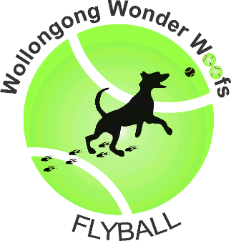

23 June 2019

JJ Kelly Park
Swan Street Wollongong

Contact - Teresa Good
Telephone: 0447 429 628 Email: wollongongwonderwoofs@gmail.com
Address: PO Box 5189 Wollongong NSW 2520

Check in @ 7.00 am
Judges Briefing @ 7.30 am
Racing Starts @ 8.00 am

Racing Format

Division 1 - Handicapped –Double Round Robin – 3 of 5 heats races

Division 2 - Regular – Double Round Robin – 3 of 5 heats races

Division 3 - Regular – Six X Round Robin – 3 of 5 heats races

Division 4 – Regular – Triple Round Robin – 3 of 5 heats races

Division 5 – Handicapped – Triple Round Robin – 3 of 5 heats races

Open Division - Handicapped – Double Round Robin – 3 of 5 heats races

In the event of a tied place there will be count backs

Points for Round Robin will be allocated as follows:
2 points for winning the race
1 point for a drawn race
0 points for a loss

In the event of a team forfeiting a race, the team left to run by itself must complete the minimum required heats to gain the Round Robin Points. If the team does not complete the minimum heats, there will be no round robin points awarded.

All racing will be conducted under the rules and regulations of the Australian Flyball Association.

All Competitors must ensure dogs are on lead when not racing and all dog faeces are disposed of in the appropriate manner.

Breakouts

All breakouts will result in a forfeit of each heat (ie, the Other Team is awarded a win).

Should the same team breakout for a 3rd time they will not be eligible to place in that division.

If the electronic timing equipment malfunctions and hand held timers are required an extra second will be subtracted from the official breakout time (manual times = 2 sec below the division’s fasted time).

Changeover Times

Teams will have 90 secs from the end of the preceding race to have their box and jumps set up and be ready to race.

The Judge will indicate when there is 30 seconds remaining. A team my forfeit the heat if they are not ready on time.

Depending on how time is going, the changeover time may change to 60 seconds after lunch.

Judges

Frank Lux
Verdelle Townsend
Lyn Clyde

AFA Representative

Brian Lindsay

First Aid Officer

Michelle Taylor

RAFFLE

RAFFLE

1 Ticket = $2

3 Tickets = $5

7 Tickets = $10

GREAT PRIZES TO BE WON

STALL

Home Made Dog Treats
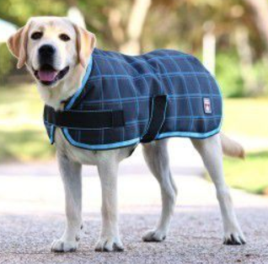

Dog Coats
Example only

Slices

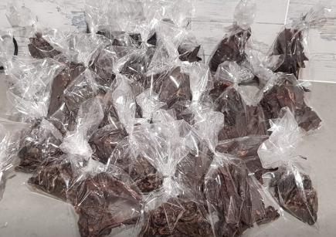

BBQ MENU

Bacon & Egg Rolls $5.00

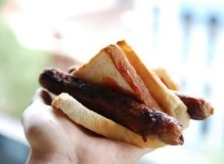

Sausage Sizzle $2.50

Cheeseburger $5.00

The Lot (cheeseburger / bacon / egg / combo) $6.00

Soft Drink $2.00

Water $1.50

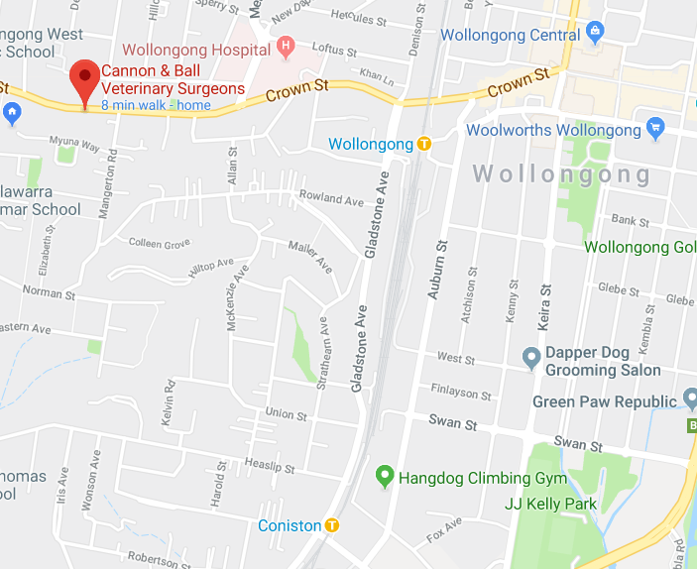

461 Crown Street
Wollongong

(02) 4229 8888

SEED TIMES & DIVISION SPLITS

Division1 | Handicapped
Team | Seed Time
Thunderdogs 1 | 16.093
Belconnen Dodgeda Bullets | 18.6
Supersonics | 19.067
Thunderdogs 3 | 19.1

Division 2 | Regular
 | Break Out: 20.0
Team | Seed Time
Thunderdogs 5 | 21.0 D – Breakout 20.0
Star Struck | 21.5 – D – Breakout 20.5
Woofers 1 | 21.8 – D – Breakout 20.8
City Slickers | 21.9 – D – Breakout 20.9

Division 3 | Regular
 | Break Out: 21.5
Team | Seed Time
Belconnen Licorice Bullets | 22.5 D – Breakout 21.5
Star Trackers | 23.571 - Web

Division 4 | Regular
 | Break Out:25.0
Team | Seed Time
Thunderdogs 6 | 26.0 – D – Breakout 25.0
Havoc Hounds | 26.0 – D – Breakout 25.0
Wylee Woofers | 26.5 – D – Breakout 25.5

Division 5 | Handicapped
Team | Seed Time
Scallywag Pirates | 27.5
Munchkins | 27.5
Belconnen Rusty Bullets | 31.5

Open | Handicapped
Team | Seed Time
Thunderdog Tsunami | 18.0
MAD Flyers’ | 22.0
Scallywag Blasting Cannons | 22.8
Kamikaze Torpedoes | 24.3

