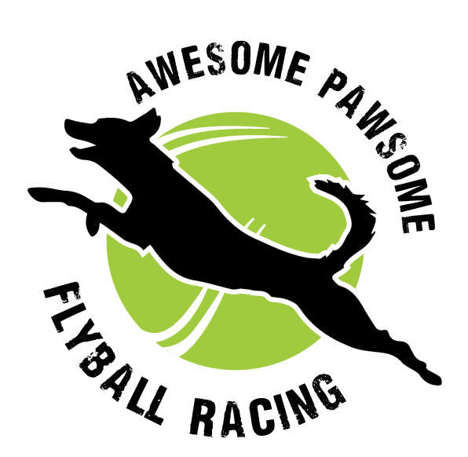
April Amateurs
ENTRIES CLOSE SATURDAY 4TH APRIL

18th APRIL 2026
RSPCA WACOL, WACOL STATION ROAD
CHECK IN 8AM
8:30AM START
AFA REP: CANDICE LEIGHTON
ORGANISER: EMMA PODMORE

Vet: Animal referral hospital. 532 Seventeen mile rocks road, sinnamon park. 07 3127 0593

Club coordinators please make sure that new members are aware of the following:
- Cars can be unloaded next to field 1 but MUST be moved to the gravel carpark or street ASAP.
- When leaving the venue, return out of the main driveway.
- Dogs are to remain on lead and in control at all times, when outside the ring.
- Dogs are only to be on Field 1 or the arena. The War Memorial and other parts of the grounds are out of bounds.
- Please stay away from the fence closest to the Black Cat Cafe.
- Dogs are to be toileted on Field 1, please dispose waste in the bins provided.
- The Black Cat Cafe will be open for refreshments.
- Please set up your crates under the awning in your club allotted area.
- Smoking on the grounds is prohibited.
TRAINING IN THE RING
- Timing allocations will depend on entries.
- All participants must have a valid CRN.
- Dogs under 12mo are not permitted to use the equipment.
- For dogs with less than 50 title points. Dogs with more than 50 points are permitted to assist, please add them to entry form.

