Welcome to the

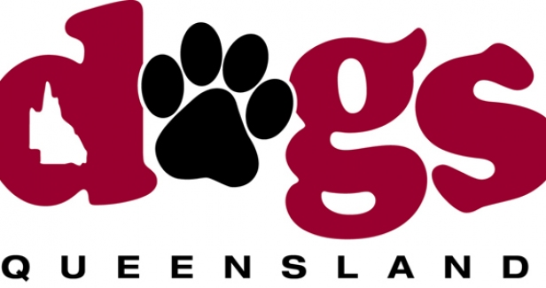
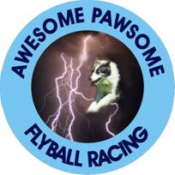
All Dog Sports Spectacular Flyball Competition 2014

Proudly hosted by Awesome

Pawsome Flyball Racing Club Inc

The All Dog Sports Spectacular is an event where the general public will be able to view first hand the many and varied sporting activities centered round our four legged canine friends. The Dogs Queensland Showground at Durack will be a hive of activity as dogs of all shapes and sizes compete in a range of activities from Rally O Obedience, Dances with Dogs, Lure Coursing, Agility, Flyball, Earthdog Trials, Canine Disc, Weight Pull and the more sedate Conformation Dog Show. There will also be Static Displays of other activities as well and Individual Breed Stalls where visitors will be able to talk to breeders about the various breeds of dogs.
Entry to the showgrounds will be by donation of a gold coin. Please circulate the pass at the end of this catalogue to be handed in with the donation at the gate. Just write Flyball where it asks for a membership number. The donation will go towards supporting the Ronald McDonald House and the visitation of The Delta Therapy Dogs to those who need the loving touch of a wonderful pooch.
The first road to the left will be closed off this year, but you can still turn left on either of the next 2 roads and make your way to the same area as last year. For those who haven’t been to this venue before, go to the back of the main building, or, alternatively, follow the sound of barking dogs. Gates open at 6AM.

Competition Organisers: Melinda Meuleman and Jennifer Crane

AFA Rep: Virgina Festing

Judge: Steve Pitt and Kevin Crane

Time Keepers: Mike McChesney & Paul Newman

Itinerary:

Check In: 8:30 AM

Judge’s Briefing: 9:00 AM

Racing starts: 9:30 AM

Two Divisions – Handicap Format

Championship Trophy

Best of 5 heats

Points for round robin will be allocated as follows:

2 points for winning the race,

1 point for a drawn race,

0 points for a loss.

In the event of a tied place teams will be ranked on “head to head” race results. (No run offs)

In the event of a team forfeiting a race the team left to run by itself must complete a minimum of three heats to claim points for a win. If the team does not complete three heats, zero points will be awarded.

Singles and doubles during the lunch break with all the noise relating to normal round robin format! Also 2 breaks of 15 minutes for beginners.

Rules & Regulations

All Competitors must ensure dogs are on lead when not racing and are to clean up after their dogs. Please dispose of poo bags in the appropriate manner.

All racing will be conducted under the rules and regulations of the Australian Flyball Association.

Changeover Times
Teams will have two minutes from the end of the proceeding race to have their box and jumps set up and be ready to race. The judge will indicate when there is thirty seconds remaining. The judge may forfeit a team if they are not ready on time.
Should teams be ready to race prior to the two minutes please indicate this to the Judge.

Catering and other info

Catering will be available at stalls throughout the day. BBQ and canteen are in area in main building opposite our ring. Water and toilets are close by. Breaks are planned throughout the day to allow everyone the opportunity to check out the other activities on display throughout the day.

Thank you to the following people for their generous donations

RAFFLE

$2 a ticket

OR

3 tickets

for $5

Voucher - donated by Robyn from Personalised Collars

3kg Supercoat Dog Food - donated by Nealle Best of AP

Noodle Box Vouchers - donated by Nealle Best of AP

Tuscany Mens Pack - Toilette spray & After Shave balm)

Wine Pack - Wine donated by Kym Roy

Sandhurst Gift Bag - donated by Anne @ Sandhurst Fine Foods

Division One –

Teams Seed Times

Awesome Pawsome One 19.200

Pine Rivers Devils 21.300

Awesome Pawsome Two 21.800

Luvadog Regardless 1 22.200

Division Two –

Teams Seed Times

Flyball Fanatics One 25.000

Pine Rivers Rebels 25.500

Awesome Pawsome Three 28.000

