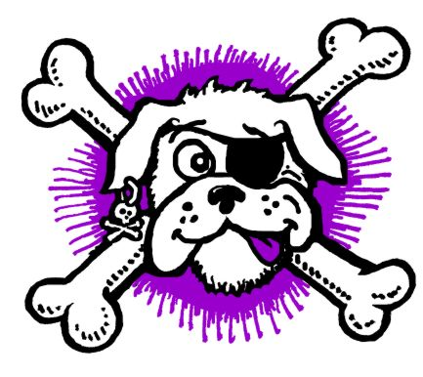

**Sydney Scallywags Flyball Incorporated**

Skulls and Crossbones at HALLOWEEN **COMPETITION**

**Sun 27th October 2024**

|  |  |
| --- | --- |
| **Location** | Princes Park. Princes Road West Auburn |
| **Check in** | 7:15 a.m. |
| **Judges briefing** | 7:45 a.m |
| **Racing commences** | 8:15 a.m. |

|  |  |
| --- | --- |
| **Judges** | Shell Gurney, Christine Bates |
| **Timekeepers** | Gavin Bland and Richard Mellon Roberta Dean & Kylie Duncan Assisting |
| **AFA rep** | Brian Lindsay |
| **Competition Organiser** | Jenni Redmond |
| **Competition Secretary** | Jenni Redmond |
| **Helpers/Assistants** | All of Sydney Scallywags |

 **PARKING ON GRAVEL / DRIVEWAY ONLY.**

**No vehicles apart from catering / merchandise allowed on grass areas**

**We suggest to bring a trolley**

Big shout out to Cumberland City Council,

who have been supporters of

Sydney Scallywags for many years

Thank you



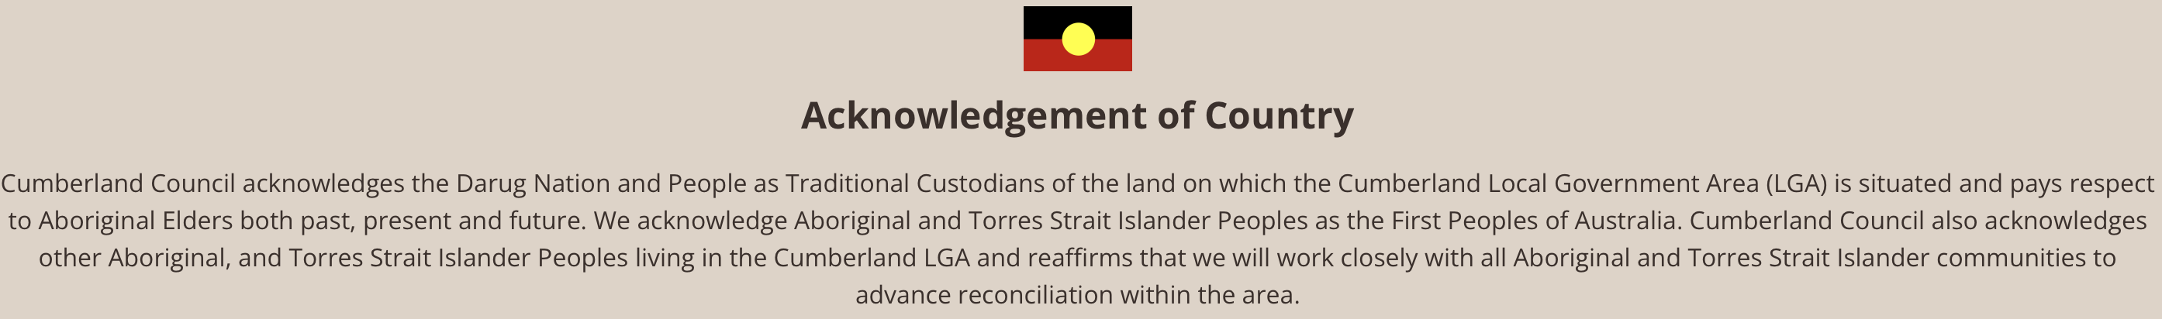

.

 **Nearest Vet. **

|  |  |  |
| --- | --- | --- |
| **Auburn Veterinary hospital**  [107A Park Rd, Auburn](https://www.bing.com/local?lid=YN3458x250586345&id=YN3458x250586345&q=Auburn+Veterinary+Hospital&name=Auburn+Veterinary+Hospital&cp=-33.85888671875%257e151.02821350097656&ppois=-33.85888671875_151.02821350097656_Auburn+Veterinary+Hospital) 2144 ·    [0296496333](https://www.bing.com/ck/a?!&&p=77ec54589076274dJmltdHM9MTY1OTQxNzg1NSZpZ3VpZD1jNDk1ZTc5Zi1mMDQ2LTQ1OTktOTE5YS01MjA0ODA0ODVmZWUmaW5zaWQ9NTUwOQ&ptn=3&hsh=3&fclid=592dfe4f-1223-11ed-9523-9cad3641e2a0&u=a1dGVsOjAyOTY0OTYzMzM&ntb=1)  Opening Hours  Saturday 9:00 AM - 1:00 PM Sunday 9:00 AM - 12:00 PM | **Fairford Rd Animal Hospital**  2 Short St, Bankstown 2200  02 9709 6844  Open Hours Mon-Fri: 9am-7pm Sat-Sun: 9am-12noon | **Animal Referral Hospital**  [250 Parramatta Road, Homebush West 2140](https://www.bing.com/local?lid=YN3724x8611350388998275598&id=YN3724x8611350388998275598&q=Animal+Referral+Hospital&name=Animal+Referral+Hospital&cp=-33.86044692993164%257e151.0732421875&ppois=-33.86044692993164_151.0732421875_Animal+Referral+Hospital) ·  [0297588666](https://www.bing.com/ck/a?!&&p=2123522ff9a2c2cbJmltdHM9MTY1OTQxODcyMSZpZ3VpZD1kMDZjOWI3Yy00MGY0LTRlODItODA5YS00ODNkNjFlODJhOWQmaW5zaWQ9NTU5MA&ptn=3&hsh=3&fclid=5d597acc-1225-11ed-b9de-f5996bde6108&u=a1dGVsOjAyOTc1ODg2NjY&ntb=1)  **Open 24 hours** |

**Catering By (eft avail).**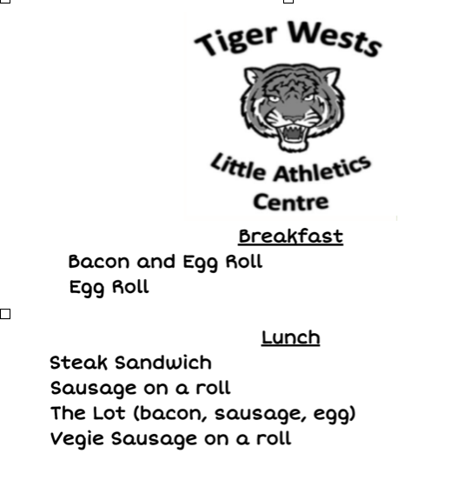

**COFFEE VAN (eft avail)**

**Thank you to all the teams who have attended and supported Sydney Scallywags Competition.**

 **LUNCH TIME TRAINING IN THE RING**

|  |  |  |
| --- | --- | --- |
| Club | no of dogs | Mins |
| Sydney Scallywags Flyball Inc | 4 | 5 |
| Norwest Flyball Club Inc | 7 | 7 |
| Coastal High Flyers | 4 | 4 |
| St George Flyball Club | 5 | 5 |
| South Coast Tsunami Flyball | 12 | 12 |
| Southern Cross Flyball Club | 9 | 9 |
| Wollongong Wonder Woofs Flyball Inc | 2 | 3 |
| Manly and District Kennel and Dog Training Club | 1 | 2 |
| Sydneysiders | 8 | 8 |
|  |  | 55 |

 **RULES AND REGULATIONS**

**• All racing will be conducted under the Rules and Regulations of the Australian Flyball Association.**

**• Count Back Rule will apply at the end of the day in the event of a tied placings as per the AFA Rules and Regulations.**

**• Stewarding - All teams are to help with stewarding throughout the day to ensure smooth running of the competition.**

**• Changeover Times - 90 seconds**

**• All competitors are required to pick up after their dogs and dispose of in the bins provided.**

**• All competitors are asked to help with the pack down of the ring at the end of the day.**

RAFFLE (eft avail )

Thanks to our many sponsors for prizes and raffle donations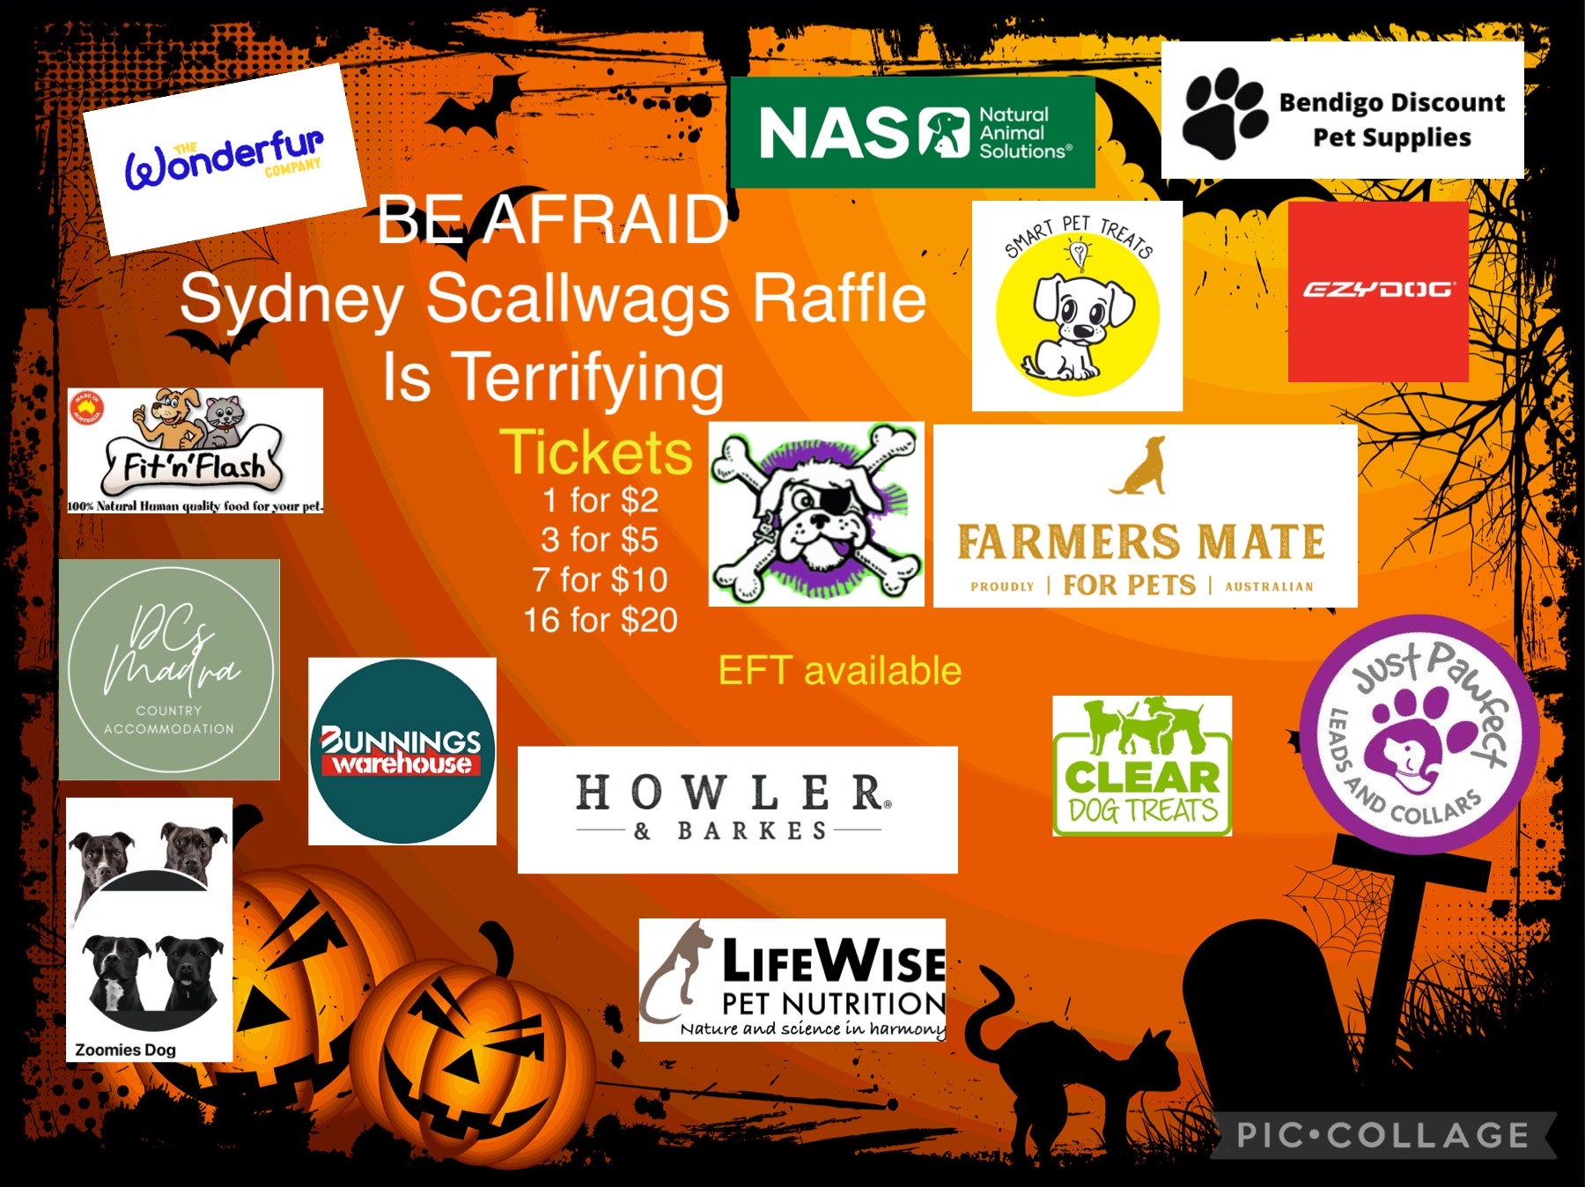

**Div Splits and Running order**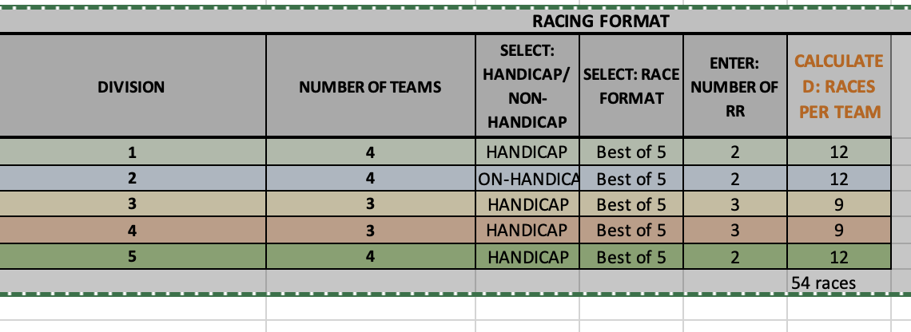

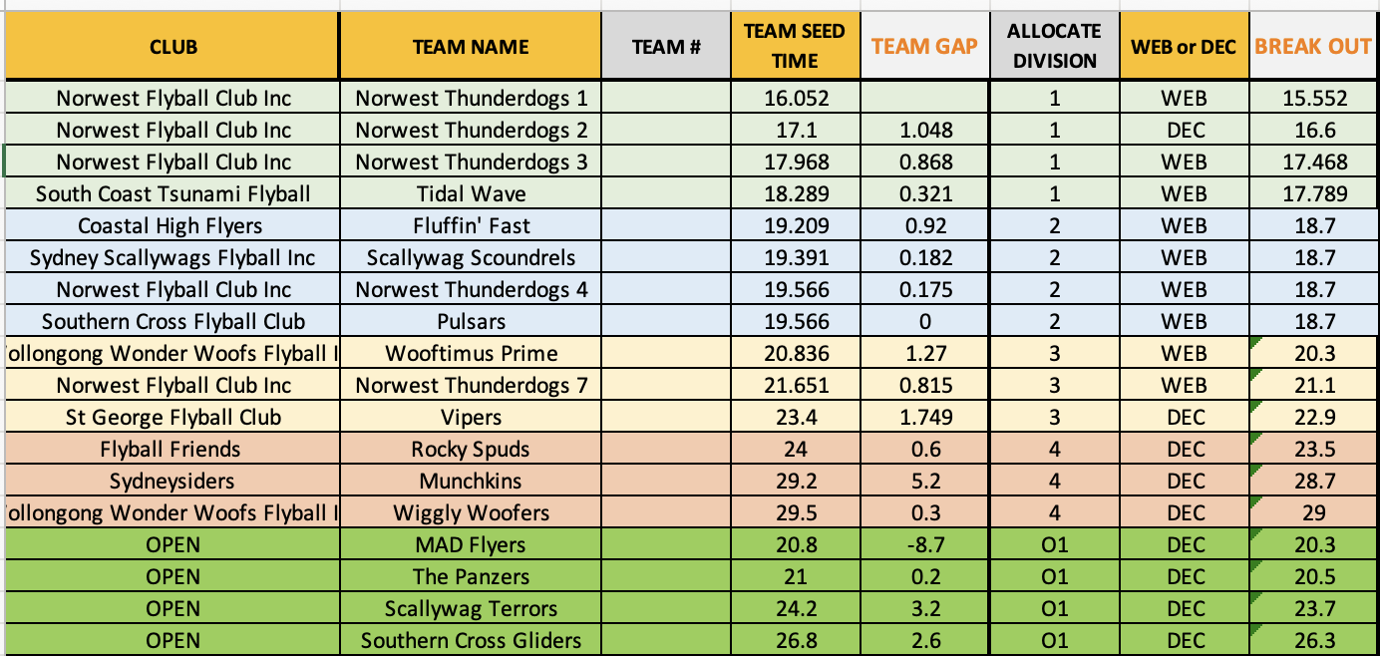

# RUNNING ORDER

