Member Motion 5
That the AFA changes the allowance of the Flyball Box dimension from 24’ in width and 18’in height to a maximum of 30” in width and 20” in height
Rationale:
I have been training and competing in flyball for over 20 years and during that time the box dimensions have essentially stayed the same. Throughout that time, we have seen the sport change considerably in such things as technique and speeds, and anything that we can do to help progress the sport and assist the dogs in a healthy longer career I would be in favor of.
Whilst we work hard on our dog’s box turns so they have a safe turn, occasionally mishaps happen where, especially in larger dogs, a leg can come over the top of the box or miss a back foot on the edge. Over the past couple of years, the AFA has made great changes in the way we measure dogs to help with jump heights, and I think moving forward this would encourage all dogs no matter size, height, or length, and give them the ability to learn great turns and I truly believe that giving larger dogs a bigger box would make the sport more inclusive for the larger breeds.
Whilst this motion alone would be beneficial it will also be complemented by the wider jumps as this will allow the dogs to come off the box straight and not have to veer back into a smaller lane width.
Lastly, many flyball organizations worldwide including UKFL, BFA, NAFA (whose regulations currently allow up to a 36”wide box) and UFLI run on larger boxes and the proposed change in box dimension to the Australian Flyball regulations would bring Australia into alignment with International Flyball organizations.
Increasing the maximum allowance will give clubs the opportunity to either run on their existing equipment and when necessary, upgrade to a box width of their choice, this is not a mandatory change. If a team likes their box size as is, they can keep it! If teams don't like it, they would at least have the option to purchase or build a box better suited to their needs

Supplies
Having spoken to Phil Lea, he is currently looking at the ability to extend the width of the current boxes in production. A variety of boxes can be obtained from overseas.

Recommendation for implementation:
- Race meetings be run with the dimensions from a start date to be set by the upcoming AFA committee and rules adjusted accordingly.

Suggested change to Rules:
Current wording
Section Appendix 1
Dimensions A box must not be more than 24 inches wide (including carry handles but excluding outdoor staking devices) or 18 inches high (including cocking devices but excluding mat grabbing devices or materials). Mat grabbing devices or materials must not raise the height of the box by more than one half inch. The body of a box must not be more than 30 inches deep (excluding any platform for the box loader to stand on). The dimensional requirements for a box are illustrated in Figure A1.1
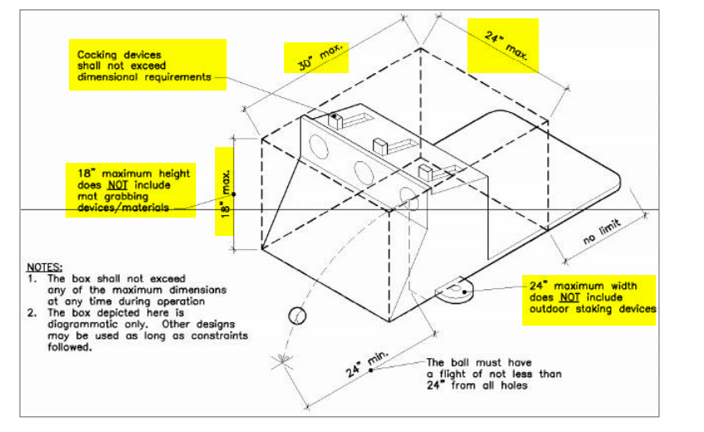

Proposed new wording
Section Appendix 1
Dimensions
A box must not be more than 30 inches wide (including carry handles but excluding outdoor staking devices) or 20 inches high (including cocking devices but excluding mat grabbing devices or materials). Mat grabbing devices or materials must not raise the height of the box by more than one half inch. The body of a box must not be more than 30 inches deep (excluding any platform for the box loader to stand on). The dimensional requirements for a box are illustrated in Figure A1.1
