Motion
To change the jump height range from the current 7”-14” to 6”-12” in accordance with the proposed revised Jump Height Measurement Chart below.
Rationale:
Flyball Organizations around the world are adopting new jump heights to accommodate the smaller dogs running. UFLI, UKFL and BFA have all sanctioned events at 6-12” jump heights.
There are advantages in lowering the jump heights to 6” for the smaller breed dogs. Many toy breed dogs are jumping above their height which will cause them to fatigue over a day of racing, causing their times to slow down as well as causing excessive wear and tear on their body over their career.
Making the smallest height 6” would make Flyball more attractive to the toy breeds who may currently be put off from doing flyball when asked to jump 7”.
If this motion is passed, any current dog racing with a 7” height card would have to be remeasured to see if they qualify to be re-classified as a 6” height dog.
All dogs who are currently measuring 13” or 14” would automatically now be classified as 12”.
Base boards of jumps will be 5” height with a 1” slat on top to give the minimum jump height of 6”.

Implementation
Changes would need to be made to the Ulna measuring device to allow for the new 6” heights to be measured accurately.
If both this motion and the motion on jump width are passed then it is proposed that they be implemented together from the 1/1/2023 to combine the changes to the jumps. It is also proposed that the AFA supplies 2 lanes of jumps to each AFA set of lights while clubs acquire their own sets.
I believe that the cost of purchasing new jumps is minimal in comparison to the safety of our dogs. An estimate of $720 for a full ring set of jumps (2 lanes) made from V-Lite (Sintra) that will include all jump bases, uprights and height slats.
This change to the Australian Flyball regulations would bring Australia into alignment with international Flyball.
Implementation considerations:
Implementation would have to be coordinated with the jump width proposal if both are passed, to avoid doubling the effort of changing over.
Clearly it will take time for all jump sets to be replaced; some clubs may need to fund raise to cover the cost and it will take time for manufacturers to supply enough jump sets. To avoid an excessively long delay, it is recommended that implementation be phased in as described below.
Recommendations for implementation:
- Race meetings be run with the new jumps from a start date to be set in consultation with manufacturers to identify when enough sets can be made, and with availability of a redesigned ulna measuring device.
- The AFA provide a set of new jumps to be attached to each light set so that race meetings can be standardized from the start date.
- A 12-month window from the start date to enable clubs to obtain their own sets of new jumps.
- If the motion to change jump width is passed at the same meeting as this motion, the same start date and time window will apply.

Suggested change to Rules:
Current AFA Measurement Chart
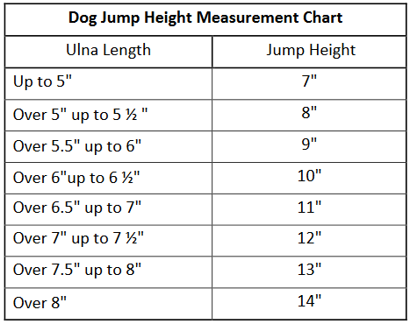

Proposed new Measurement Chart
Ulna Length | Jump Height
Up to 4.5” | 6”
Over 4.5” up to 5” | 7”
Over 5” up to 5.5” | 8”
Over 5.5” up to 6” | 9”
Over 6” up to 6.5” | 10”
Over 6.5” up to 7” | 11”
Over 7” | 12”

Changes to include:
- Adding a row to the table
Up to 4.5” | 6”
- Changing “Up to 5” to “Over 4.5” up to 5” for Jump Height 7”
- Removing the rows for 13” and 14”
- Changing “Over 7” up to 7.5” to “Over 7” for the jump height 12”

Changes to the Equipment standards
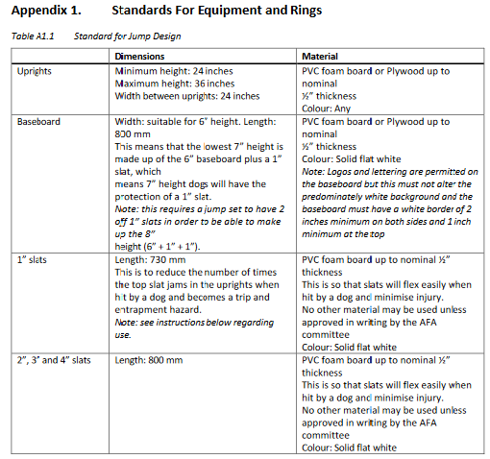
Proposed new wording
Baseboard | Width: suitable for 5” height. Length:  800 mm  This means that the lowest 6” height is made up of the 5” baseboard plus a 1” slat, which means 6” height dogs will have the protection of a 1” slat.  Note: this requires a jump set to have 2 of 1” slats in order to be able to make up the 7” height (5” + 1” + 1”). | PVC foam board or Plywood up to  nominal ½” thickness  Colour: Solid flat white  Note: Logos and lettering are permitted on the baseboard but this must not alter the predominately white background and the baseboard must have a white border of 2 inches minimum on both sides and 1 inch minimum at the top

