Motion
That the AFA change the width of the jumps from the current 24” between the uprights to 30”.
Rationale:
The reason behind this proposal is to improve the safety of our dogs. Flyball is ever evolving as we strive to train our dogs to run faster with closer passes. As the handlers and dogs improve, there is less room for error. A slight ball fumble and despite the best of intentions, a close pass may mistakenly progress into a crossing in the lane with the risk that the dogs could collide, at speed, into each other or crash with a jump upright.
UKFL, BFA, UFLI and NAFA, have implemented this change to jump widths either permanently or are currently undergoing implementation trials with the focus on improving dog safety. The proposed change in jump widths to the Australian Flyball regulations would bring Australia into alignment with International Flyball organisations.
Nobody aims to have the dogs cross in the racing lane, however, even with the most experienced handlers, mistakes can happen. By making the jumps wider we give the dogs the space to avoid a collision injury which could damage a dog’s confidence or force an extended layoff, early retirement or worse. The photos below clearly show how an extra 6” can improve the dog’s safety in the event there is an early cross.
Comments from competitors in the UK, have mentioned that the number and severity of accidents has dramatically decreased since changing to the 30” wide jumps. To confirm this, a member of the current AFA committee has contacted many current members of the UKFL and BFA who have all agreed in their opinion, that since the increase in jump width there has been a significant reduction in incidents regarding collisions of dogs and/or jumps
A few additional considerations.
Cost: An estimate of $720 for a full ring set of jumps (2 lanes) made from V-Lite (Sintra) that will include all jump bases, uprights and height slats.
Cost Considerations - Does the whole jump need to be replaced or can some components be reused, such as the uprights?: Some uprights may need to be replaced if the new bases won’t fit or hold the uprights up straight. This may have a bigger impact if the motion to change Jump Heights is implemented at the same time.
Based on overseas experience:
- How do dogs react to the change?
- Is there any evidence that they can go back and forth without issues? (eg if comps were run at 30” before all clubs had the new size, ie were still training at 24”)
Feedback has been that dogs have not had an issue switching between the 2 jump widths, but the incident of collision has been reduced dramatically. Reference the quote from Sam
Implementation considerations:
Implementation would have to be coordinated with the jump heights proposal if both are passed, to avoid doubling the effort of changing over.
Clearly it will take time for all jump sets to be replaced; some clubs may need to fund raise to cover the cost and it will take time for manufacturers to supply enough jump sets. To avoid an excessively long delay, it is recommended that implementation be phased in as described below.
Recommendation for implementation:
- Race meetings be run with the new jumps from a start date to be set in consultation with manufacturers to identify when enough sets can be made.
- The AFA provide a set of new jumps to be attached to each light set so that race meetings can be standardized from the start date.
- A 12-month window from the start date to enable clubs to obtain their own sets of new jumps.
- If the motion to change jump heights is passed at the same meeting as this motion, the same start date and time window will apply.
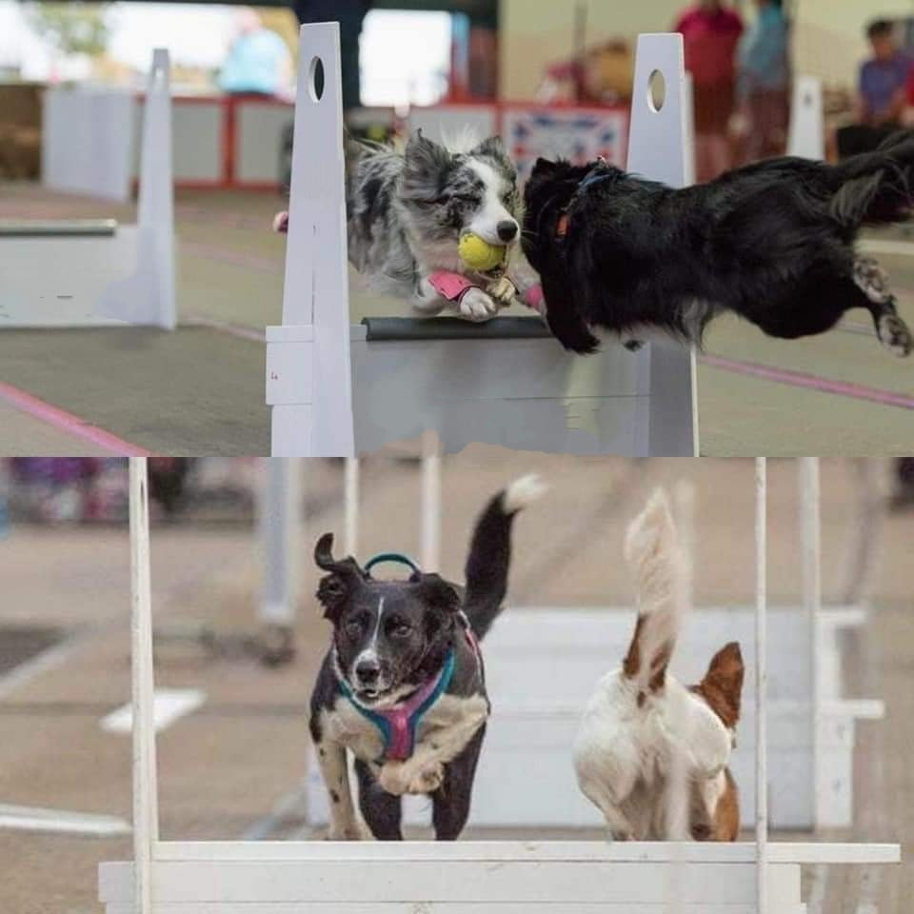
Photos used with permission from Claire Kennedy
Suggested change to Rules:
Current wording
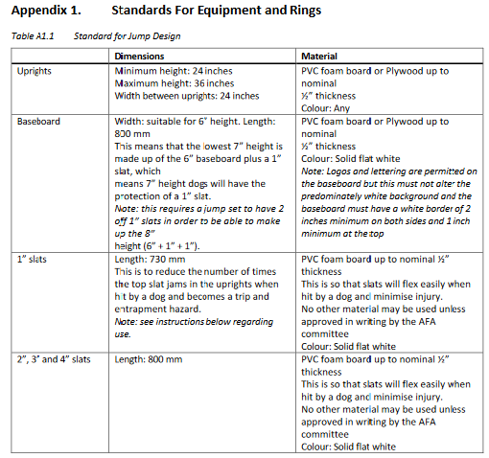
Proposed new wording
Uprights | Minimum height: 24 inches  Maximum height: 36 inches  Width between uprights: 30 inches | PVC foam board or Plywood up to  nominal ½” thickness  Colour: Any
Baseboard | Width: suitable for 6” height. Length:  950 mm  This means that the lowest 7” height is  made up of the 6” baseboard plus a 1”  slat, which means 7” height dogs will have the protection of a 1” slat.  Note: this requires a jump set to have 2 off 1” slats in order to be able to make up the 8” height (6” + 1” + 1”). | PVC foam board or Plywood up to  nominal ½” thickness  Colour: Solid flat white  Note: Logos and lettering are permitted on the baseboard but this must not alter the predominately white background and the baseboard must have a white border of 2 inches minimum on both sides and 1 inch  minimum at the top
1” slats | Length: 880 mm  This is to reduce the number of times  the top slat jams in the uprights when  hit by a dog and becomes a trip and  entrapment hazard.  Note: see instructions below regarding  use. | PVC foam board up to nominal ½”  thickness  This is so that slats will flex easily when hit by a dog and minimise injury.  No other material may be used unless approved in writing by the AFA committee  Colour: Solid flat white
2”, 3” and 4” slats | Length: 950 mm | PVC foam board up to nominal ½”  thickness  This is so that slats will flex easily when hit by a dog and minimise injury.  No other material may be used unless approved in writing by the AFA committee  Colour: Solid flat white

