As at close of business Friday 3rd August 2018 the AFA had received 2 Motions from members for submission to the 2018 AGM for show of hands voting on the night. The Motions are shown below in order to allow members to have maximum time to consider the proposals.

Motions Submitted to 2018 AFA AGM.

MOTION 1. (submitted by member Samantha Brown CRN 2626).
That the AFA adopt the ulna length measuring device and associated jump heights chart, as outlined in the detailed wording below, in place of the withers measure approach and that the wording of the Rules be amended as shown below.

YES / NO

Background:
The system that we use at the moment can be unfair to dogs that are deep chested with shorter legs or for the many dogs that don’t like the measuring device and thus not be able to be measured accurately or even at all. By replacing the current system with a method that is being used in many countries, including America, Great Britain, South Africa, The Czech Republic, France and Portugal and is currently in the process of being introduced in Germany – which is getting Dogs to be measured from the point of the Elbow to the Accessory Carpal Bone (Pisiform) - the bony protrusion just above the stop or carpal pad.

The motion involves four parts;

Part 1 : Replace Part (j), Chapter 6, Section 6.1 in its entirety from the AFA Rule Book with the following;
A dog’s jump height shall be determined by taking a measurement of the Ulna (See Figure 6.1A) using an approved device supplied by the association (See figure 6.1C). The measurement shall be taken by setting the dogs front leg in two 90 degree angles. A measurement shall be taken from the wrist to the point of the elbow (see figure 6.1B). The measuring judge shall support the forearm (ulna) to the curved surface of the device and slide the mechanism towards the elbow, the mechanism shall be then secure in place and removed from the leg. The judge shall then measure the length and determine the dog’s height from the chart provided below.
Table 6.1 Dog Jump Height Chart

Ulna Length | Jump Height | Ulna Length | Jump Height
Up to 5" | 7 | Over 6.5" - 7" | 11
Over 5" - 5.5" | 8 | Over 7" - 7.5" | 12
Over 5.5" - 6" | 9 | Over 7.5" - 8" | 13
Over 6" - 6.5" | 10 | Over 8" | 14

Figure 6.1A Dog Ulna (Front Leg) Measurement Location
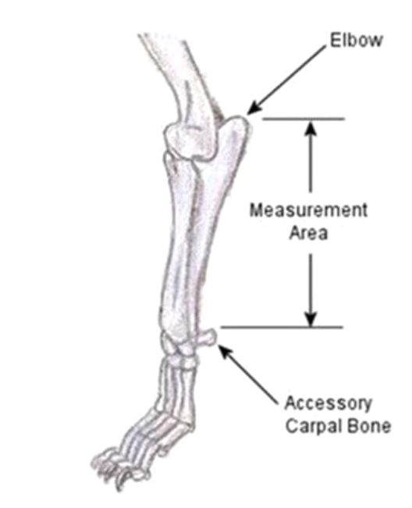

Figure 6.1B – Leg position for taking the measurement
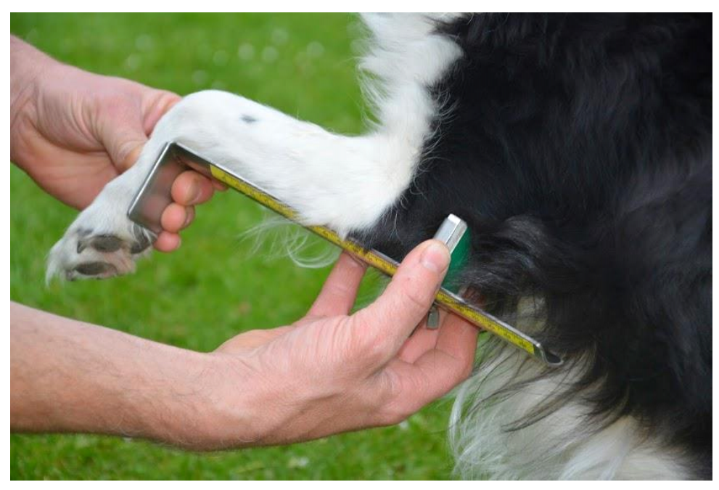

Figure 6.1C – Measuring Device

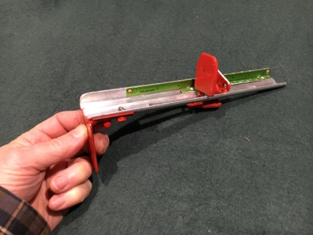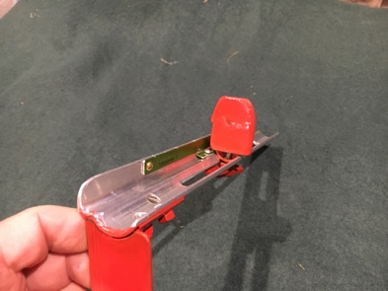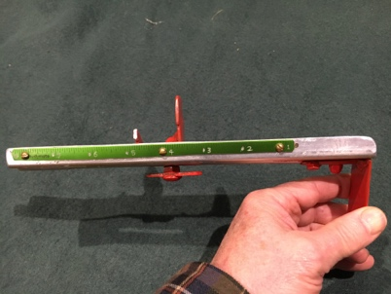

Part 2 Replace Part (c), Chapter 3, Section 3.3 in its entirety from the AFA Rule Book with the following;
Jump heights shall be set as per Section 6.1.

Part 3
Remove Part(d), Chapter 3, Section 3.3

Part 4
That the Committee develop appropriate wording in the Rules to provide that all existing height cards shall remain in effect and a dog may continue to jump the height issued on the height card. However, a member may elect to apply for a new height card under the new system and a new height card shall be issued for the dog based on the adopted height Table 6.1.
Height cards issued under the previous system shall remain challengeable as per section 6.5 of the rule book and the AFA shall maintain AFA approved measuring wickets until no more height cards exist under the previous system. Any challenge to a height card issued under the previous system shall be measured and checked using the previous rules including deducting 5” from the height of the dog at the withers then rounding down to the nearest whole number.
FAQ
1 – Why are we proposing to changi the way we measure?
- The reason for this motion is 2 fold, firstly to make it fair for all dogs no matter what their body shape, to jump at a height that is relevant to their leg length rather than their wither height and secondly for those dogs who are fearful of the existing measurement process and thus cannot get an accurate method. The measuring device proposed above makes the new system fairer and easier on dogs, handlers and judges.

2 – I already have a measurement card – what happens now?
- One Ulna measure for a dog with an existing height card does not invalidate the existing height card. That only happens if the height card process is completed for the Ulna system. Basically, you can try-before-you-buy if you want to without it endangering your existing card.
- However, please note, a dog cannot simultaneously have a height card under the withers system as well as the Ulna system. Once the Ulna process is completed, the withers card will be withdrawn.

3 – How did you come up with the conversion table?
- The table is based on the rules provided by UKFL and UFLI

4 – Do you have any examples of dogs using this method before and after?
- Yes, I have measured many dogs at shows and the most interesting one is a case of two Staffordshire bull terriers:

Two Staffordshire Bull Terriers have been measured using the current system – Dog A at 9” and Dog B at 7”. At the moment dog A hits the jumps due to the depth of her sternum.
Both had the leg measurements taken and measured at 4’ and using the system above, both dogs would be running at 7” allowing Dog A and Dog B to run at their full potential.
Motion 2 Submitted by Robyn Ferguson CRN 2492

That the AFA amend the wording of Section 1.4 (b) so that the wording reads “Teams can also elect to use a declared seed time which must be accompanied by a written justification on the entry form as to why they are using a declared time. If a team uses a declared seed time which is slower than the time listed on the AFA website under Seed Times it must be at least one (1) second slower than the listed Seed Time (egg website time is 25.452 therefore the team must enter a seedtime of 26.452 or slower). You can declare a faster time than the time listed but there is no minimum to this amount (egg Website time is 23.213, you can declare a time less than a second faster i.e. 23.000).

The declared seedtime must be based on the assessed minimum time of the team”.

YES NO

Rationale

Although Section 1.4(b) is lengthy, my change is only the last sentence.

I believe the suggested wording is generally the current practice of team organisers/selectors. By removing the reference to ‘4 fastest dogs’ it takes out the ambiguity of whether a height dog should or shouldn’t be included and whether the time of the 4 fastest dogs should be taken over their own or lower heights and whether fastest times or fastest average times should be used.

Webtimes are the actual minimum time of the team, regardless of the racing line up and seedtimes should be assessed on the estimated minimum time, regardless of the racing line up.

The AFA Committee does not have the required information (i.e. an individual dog’s racing times or averages) nor do they have the capacity to scrutinise all seedtimes so making reference to the 4 fastest dogs is unenforceable. The current penalty for an incorrect seed time only occurs with a team breaking out or sandbagging. The proposed change to the wording will not affect the penalty for submitting an incorrect seed time.

